- Login into SIS.

- Access the TRX.D.SUM process for the student you are reviewing, and print out page one (1) of this process. You will need it as part of your submission review.

- Record the student’s current GPA data needed for your calculation:
Value A – Graded Units as shown on TRX.D.SUM – see “GPAU” field: __________
Value B -- Grade Points as shown on TRX.D.SUM – see “Gpts” field: __________
Value C -- Current GPA as shown on TRX.D.SUM – see “GPA” field: __________

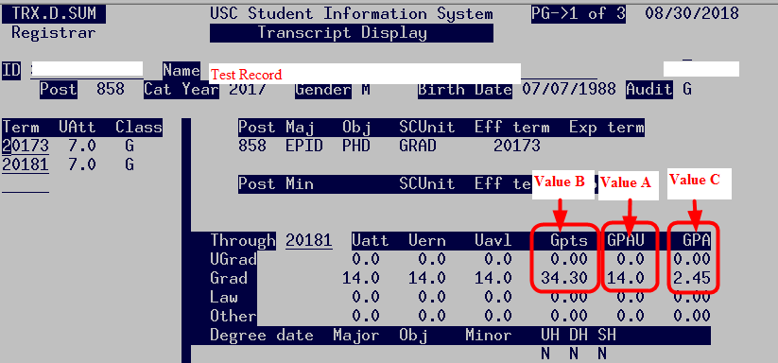

Value D -- The number of units the student is enrolled in, and/or is planning to enroll in: ________
Value E -- The GPA the student is trying to attain: _________
Apply these numbers to your Excel Worksheet, and print the results of your calculation. Send to Degree Progress and the Graduate School this worksheet, the printed Excel worksheet with numbers, and the TRX.D.SUM screen printout. This will be used to verify your calculations.
NOTE: When saving the Excel file, use the ‘Save As’ option and rename the file with a portion of the student’s name or ID.

