Section Scheduling Form User Manual
  - Curriculog

For USC scheduling coordinators and approvers
This User Manual was prepared by the Classroom Scheduling Office to provide guidance for the functions and use of the Section Scheduling Form in Curriculog.
Table of Contents
Glossary 3
General Information 4
Access to the Section Scheduling Form 5
For Scheduling Coordinators: How to Start a New Proposal 6
For Scheduling Coordinators: How to Request “ADD Section” 17
For Scheduling Coordinators: How to Request “CHANGE Section” 21
For Scheduling Coordinators: How to Request “CANCEL Section” 24
For Scheduling Coordinators: How to “SAVE ALL CHANGES” 25
For Scheduling Coordinators: How to “VALIDATE AND LAUNCH PROPOSAL” (SUBMIT A PROPOSAL) 28
FOR Scheduling Coordinators and Approvers: Workflow General Information and Progress Tracking 32
1. Dornsife Departments: General Use Classroom: 33
2. Dornsife Departments: Department-Owned Classroom/Online: 35
3. All Other Departments: 36
For Dornsife Curriculum Office: How to Approve a proposal 37
For Dornsife Curriculum Office: How to Reject a Proposal 41
For Scheduling Coordinators: How to Re-Launch (re-submit) a rejected proposal 42
How to set up Email Notifications 45
How to search for a proposal 50
For Scheduling Coordinators: 50
For Approvers: 53
For Scheduling Coordinators and Approvers: 54
For questions and issues 57

Glossary
Proposal – The request you create and submit in Curriculog.
Reject – Used in the Decisions tool to return the proposal to the initiator
Validate and Launch – A command that submits your proposal and moves it to the next workflow step.
Re-launch – A command to re-submit the proposal that was returned to you for further editing.
Cancel – The action of “Deletion” is replaced with “Cancel.”

General Information
Purpose: The Section Scheduling Form is used by USC’s scheduling coordinators and approvers for the following purposes:
- Adding a new section;
- Making changes to an existing section;
- Canceling an existing section.

Workflow Steps: Dornsife College:
- The proposal is submitted by a scheduling coordinator;
- The proposal moves to Dornsife Curriculum Office for approval;
  - If the request if not approved, it will be returned to the initiator.
- If approved, the proposal moves to the Classroom Scheduling Office for their approval for general-use classroom requests.
- Once approved by Classroom Scheduling, the proposal reflects a “complete” status, and the scheduling coordinator receives a confirmation email.
- If the proposal is rejected and returned to the scheduling coordinator, the same proposal is edited and re-submitted for the same workflow approval cycle.

Workflow Steps: Non-Dornsife Departments:
- The proposal is submitted by a scheduling coordinator;
- The proposal moves to the Classroom Scheduling Office for approval;
- Once approved by Classroom Scheduling, the proposal reflects a “complete” status, and the scheduling coordinator receives a confirmation email.
- If the proposal is rejected and returned to the scheduling coordinator, the same proposal is edited and re-submitted for the same workflow approval cycle.

Access to the Section Scheduling Form
Access to Curriculog:
Link: https://usc.curriculog.com/
Click Login and enter Curriculog with your USC single sign-on access.
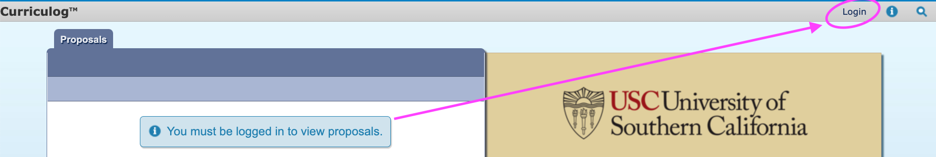

For Scheduling Coordinators: How to Start a New Proposal
- Click New Proposal:
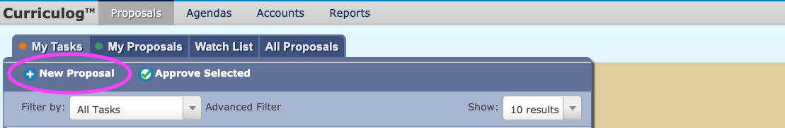
- The 00 Section Scheduling Form is on the top of the forms list:
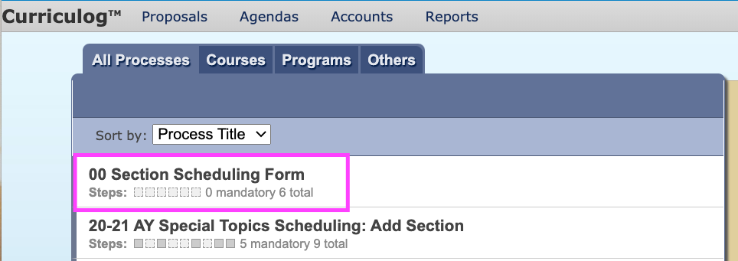
- Click on the form and the checkmark will become visible. Click on the checkmark to Start Proposal:
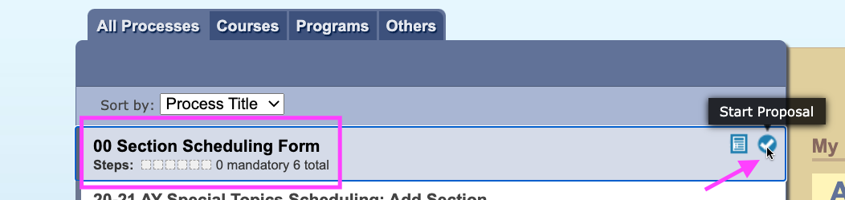

4. When you start a new proposal, Curriculog will assign a unique URL to the proposal (circled below).
NOTE: It is recommended to save the unique URL for further reference (refer to p. 54).
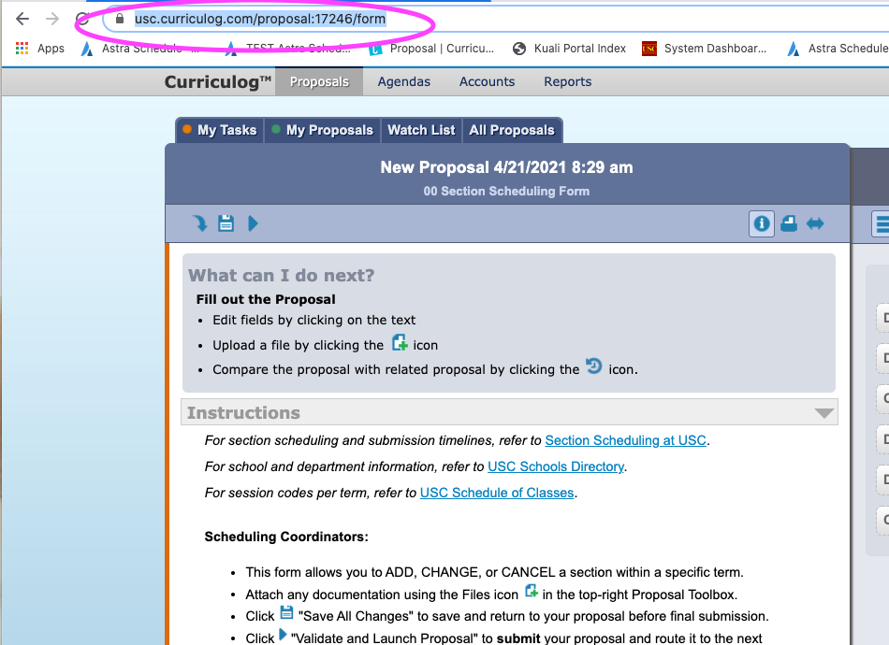

- The Instructions part of the form provides general information about the steps of a proposal submission and the approval process for the scheduling coordinators and approvers:
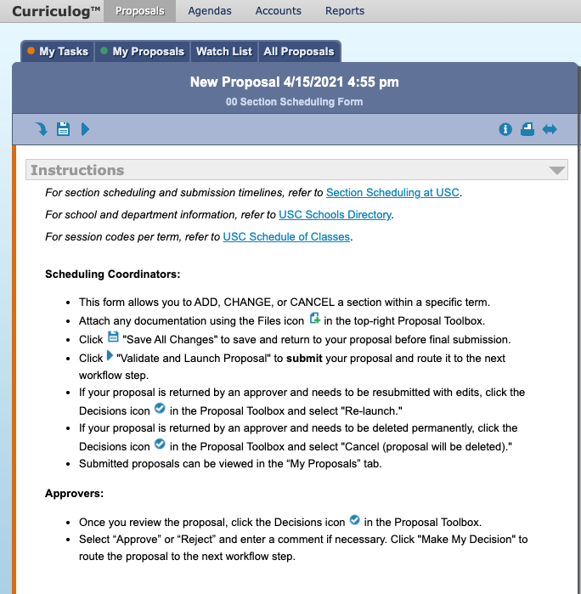

- Select the term (e.g. Summer 2021, Fall 2021) and the action (Add, Change, Cancel) in the Scheduling Action Requested field of the form:

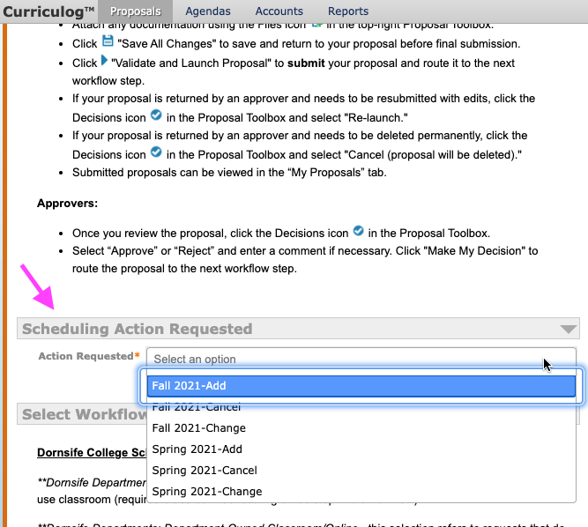

- Select Workflow: In this field, you will determine whether your proposal should go through the Dornsife Curriculum Office’s approval process, or it should go directly to the Classroom Scheduling Office.
- If you are a Dornsife College scheduling coordinator and will be requesting a general-use classroom, please click Dornsife Departments: General-Use Classroom (except for ALI, JS, HEBR, NEUR, NSCI – please see “All Other Departments” on p. 10):

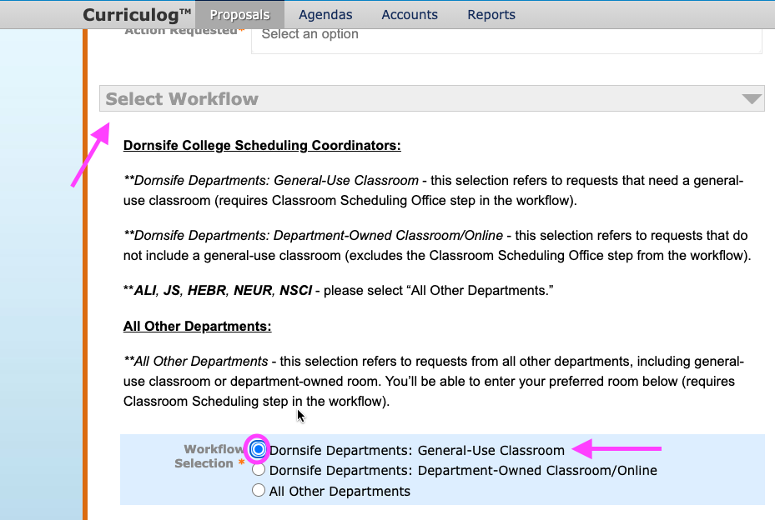
NOTE: This selection adds the Dornsife Curriculum Office and the Classroom Scheduling Office to the workflow approval process.

- If you are a Dornsife College scheduling coordinator and will be requesting a department-owned/non-general-use classroom or ONLINE, please click Dornsife Departments: Department-Owned Classroom/Online (except for ALI, JS, HEBR, NEUR, NSCI – please see “All Other Departments” on p. 10):
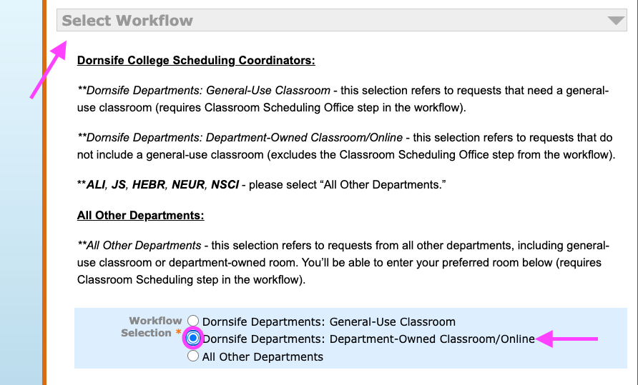
NOTE: This selection adds the Dornsife Curriclum Office to the workflow approval process but excludes the Classroom Scheduling Office.

- If you are a NON-Dornsife College scheduling coordinator or an ALI, JS, HEBR, NEUR, NSCI scheduling coordinator and will be requesting a general-use classroom or department-owned/non-general-use classroom or ONLINE, please click All Other Departments:
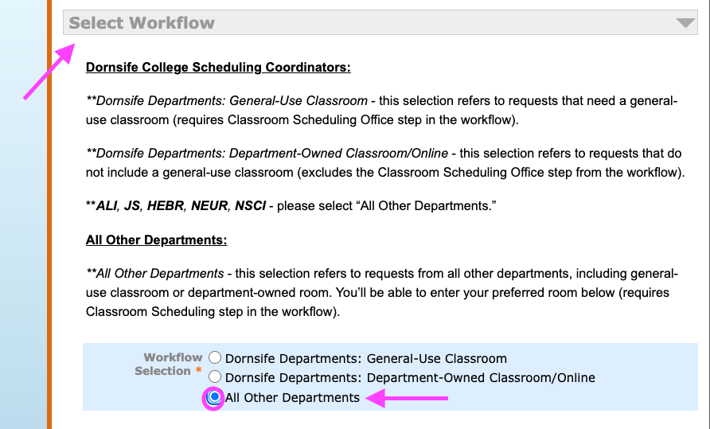
NOTE: This selection directly and only adds the Classroom Scheduling Office to the workflow approval process.

- Enter Scheduling Coordinator Information: In this field, the scheduling coordinator will enter their own USC School- and Department-related information. All fields are required [*].
[TIP: By clicking the “i” button at the top of the form, the user can activate the Help Text for data entry guidance starting from “Enter Scheduling Coordinator Information” field to the end of the form.]
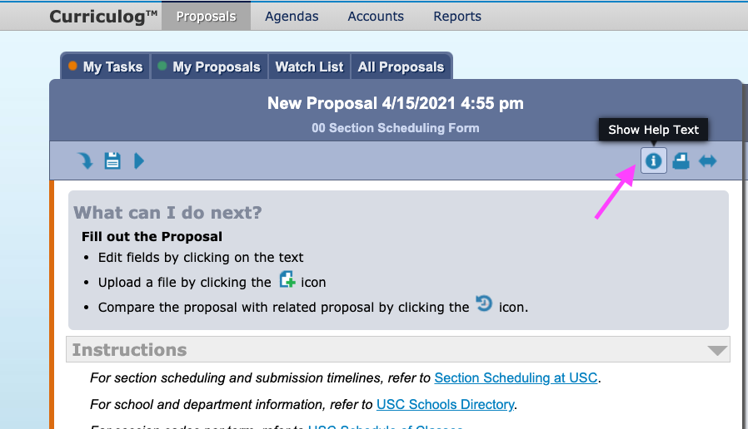
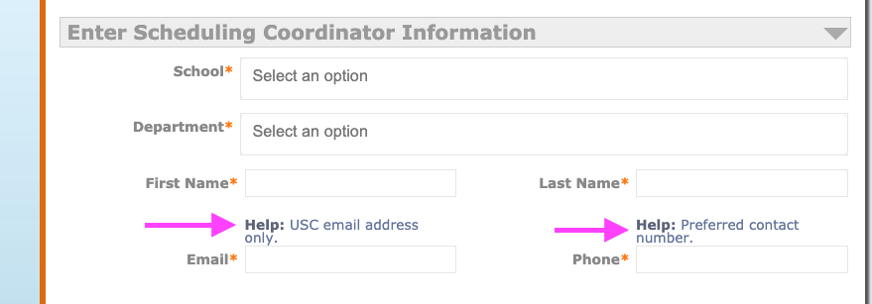
NOTE: Help Text can be turned on or off at any time:

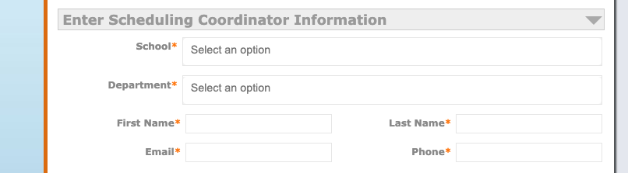

- Enter Scheduling Coordinator Information:
First, select your School from the drop-down list:
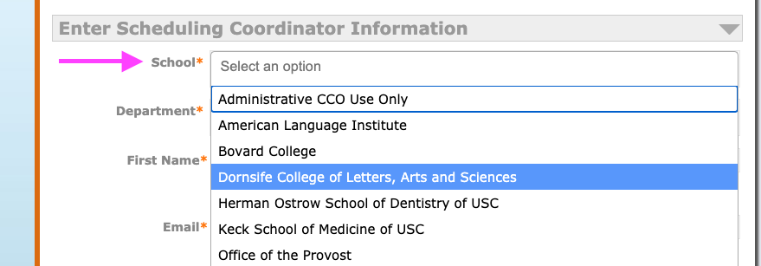

Second, select your Department from the drop-down list:
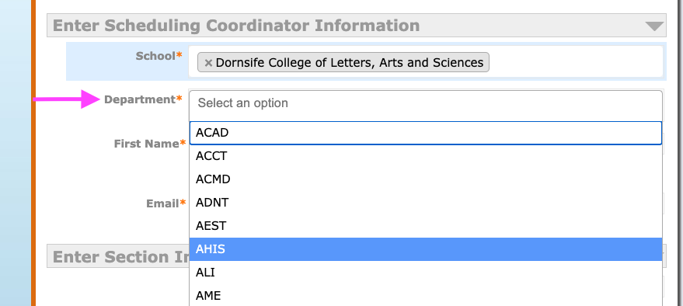

Third, the scheduling coordinator manually enters their First Name, Last Name, USC Email address, and a contact number (Phone):
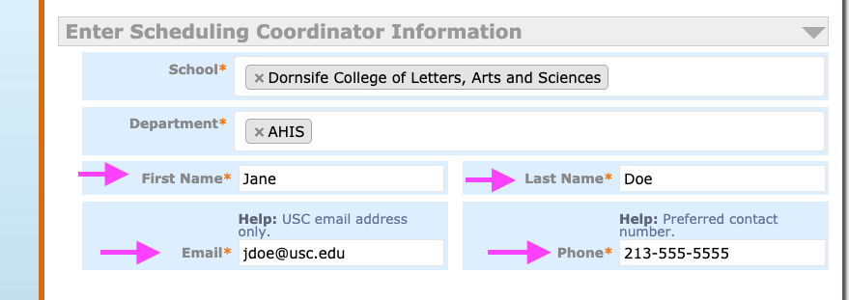
- Enter Section Information: In this part of the form, the scheduling coordinator manually enters all the required section information regardless of the selected term and action (e.g., Fall 2021 Add, Fall 2021 Change, Fall 2021 Cancel).
Fields marked with a red asterisk [*] are required. If a required field is left blank, the proposal cannot be submitted.
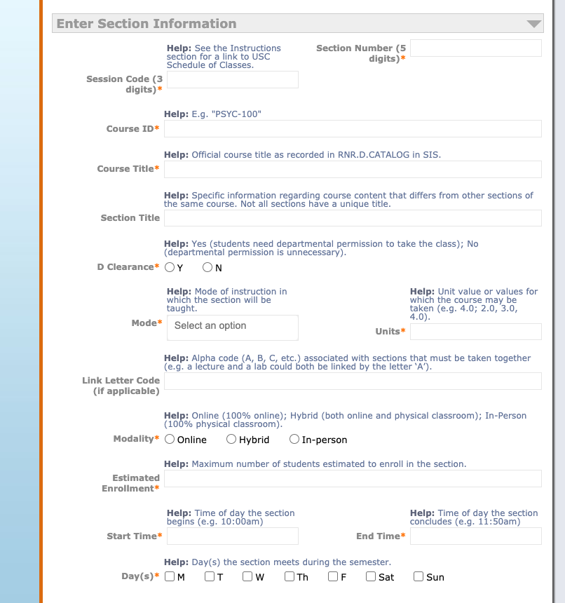
Example with Completed Fields:
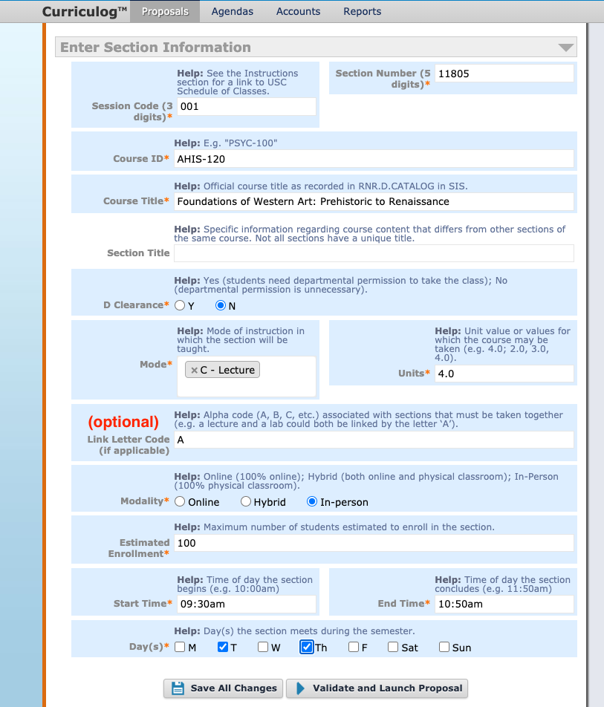
NOTE: If multiple numbers of units need to be entered, please list them all: e.g., 1.0, 2.0, 3.0, 4.0, 5.0, 6.0.

For Scheduling Coordinators: How to Request “ADD Section”
- If the scheduling coordinator requests a section to be added to the term, they will select the term with “Add” option in the Scheduling Action Requested field (refer to p. 7):
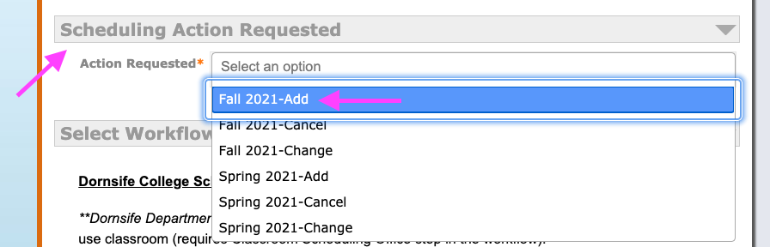

Add Section: In this part of the form, the scheduling coordinator enters all required information and any optional information needed to add a section in SIS.
All required fields are marked with a gray asterisk [*].
NOTE: Help Text is on for the user’s convenience.
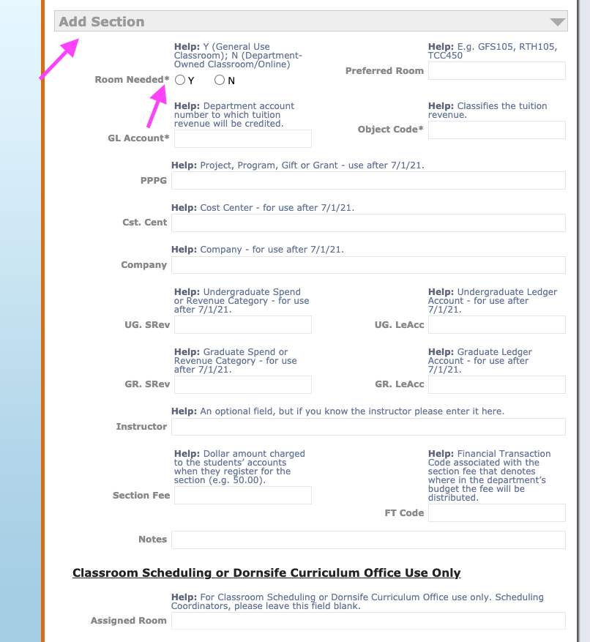

Room Needed: Select Y for Yes if a general-use or department-owned room or Online is needed for the section. Select N for No if no room is needed. This is a required field.
If there is a preferred room (general-use, department-owned, Online), manually enter it in the Preferred Room field. This is an optional field.
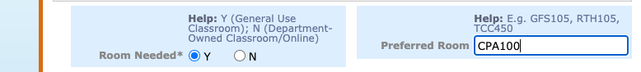
GL Account & Object Code: The scheduling coordinator manually enters the section’s GL Account and Object Code. These are required fields.

PPGG, Cst. Cent, Company, UG. SRev, UG. LeAcc, GR. SRev, GR. LeAcc:
Please leave these fields blank. These fields will be used and will be required fields starting from July 1, 2021.
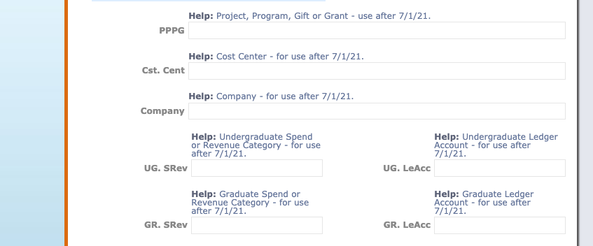

Instructor: The scheduling coordinator manually enters the name of the instructor if it is known.
NOTE: Having the instructor’s name in SIS helps the CS Team with room assignments for the instructor’s back-to-back classes.
Section Fee & FT Code: The scheduling coordinator manually enters the information if needed.
These are optional fields.
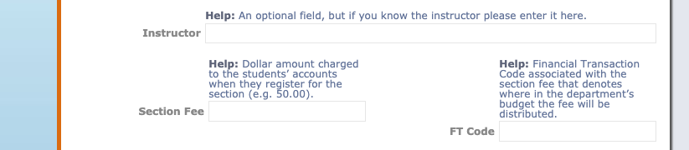
Note: The scheduling coordinator manually enters additional information to this field. For example, if a section has multiple meetings, the information regarding the remaining meetings can be added here. This is an optional field.
Assigned Room: This field is ONLY for the Dornsife Curriculum Office or Classroom Scheduling use, where a room is assigned to the section by either office. Please leave this field blank. This field will be populated at the final stage of the approval process.
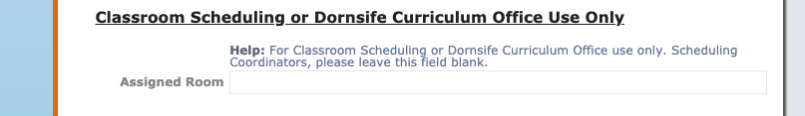

For Scheduling Coordinators: How to Request “CHANGE Section”
If the scheduling coordinator requests a change/changes to an already existing section in the term, they will select the term with “Change” option in the Scheduling Action Requested field (refer to p. 9):
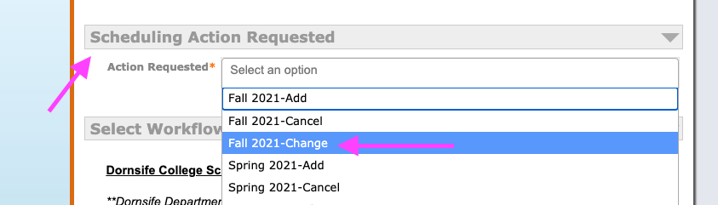

Change Section: If the scheduling coordinator would like to make a change/changes to a section, they will manually enter ONLY the new information to indicate the change(s) to the section. Please do not enter the information that will remain the same.
“Students Contacted?” is the only required field here and it is marked with a gray asterisk [*]. Please select Y for Yes or N for No.
NOTE: Help Text is on for the user’s convenience.
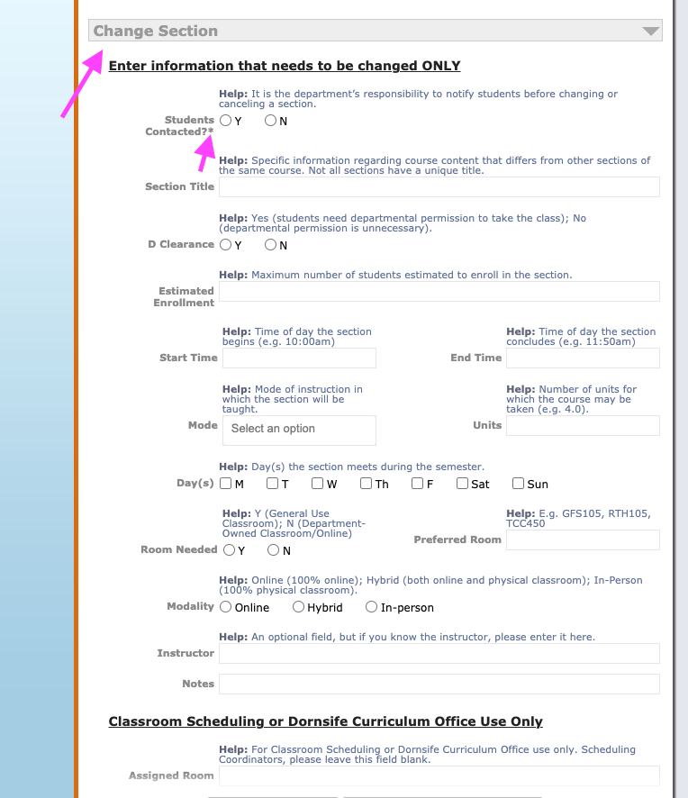
Notes: The scheduling coordinator manually enters additional information to this field. For example, if a day change from Monday to Wednesday is requested, but Friday might be a second option as well, the second option can be entered here. This is an optional field.
Assigned Room: This field is ONLY for the Dornsife Curriculum Office or Classroom Scheduling use, where a room is assigned to the section by either office. Please leave this field blank. This field will be populated at the final stage of the approval process.

For Scheduling Coordinators: How to Request “CANCEL Section”
If the scheduling coordinator would like an already existing section to be cancelled, they will select the term with “Cancel” option in the Scheduling Action Requested field (refer to p. 9):
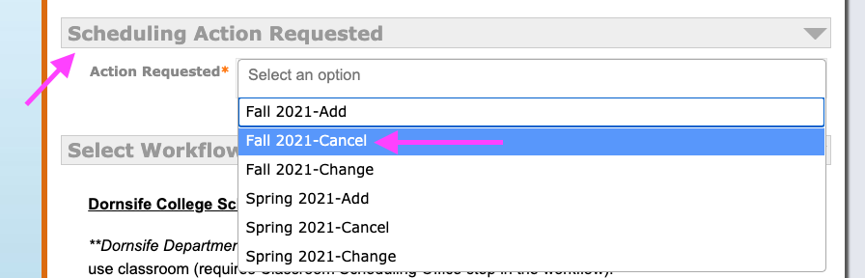

Cancel Section: The scheduling coordinator manually enters the information in this field. In the “Students Contacted” field, please select Y for Yes or N for No.
All fields are required and marked with a gray asterisk [*].
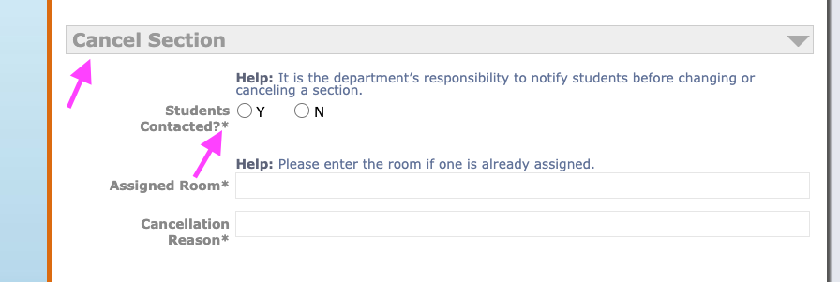

For Scheduling Coordinators: How to “SAVE ALL CHANGES”
At any stage of your data entry and before you submit your proposal, you can Save All Changes and return to your proposal at any time in the future.
You can save your proposal before you complete it in two ways:
- Click Save All Changes, which is always visible at the bottom of your screen (circled below) at all stages of your data entry (as you scroll up or down the form, the “Save All Changes” option remains in view at all time):
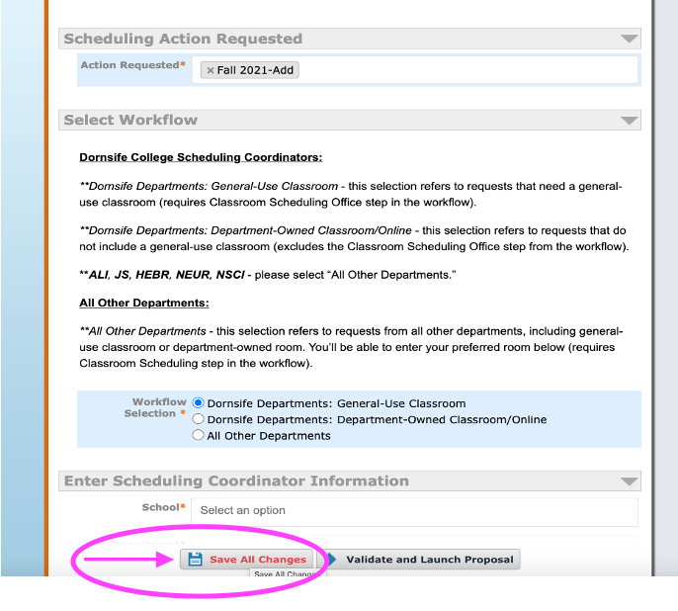

- Or, click Save All Changes (the disk icon) at the top of the form:
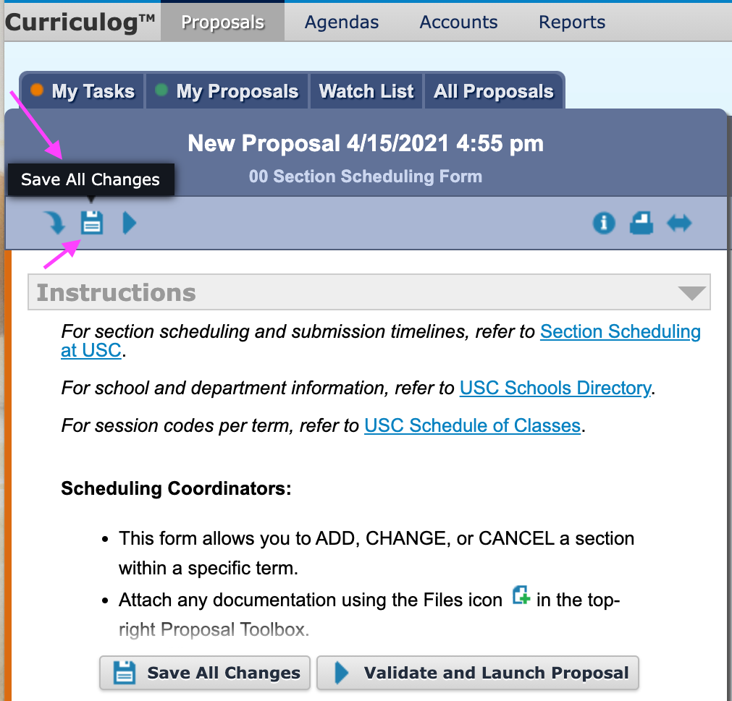

After you Save All Changes, the name of the form will be updated in accordance with the section information you’ve entered:
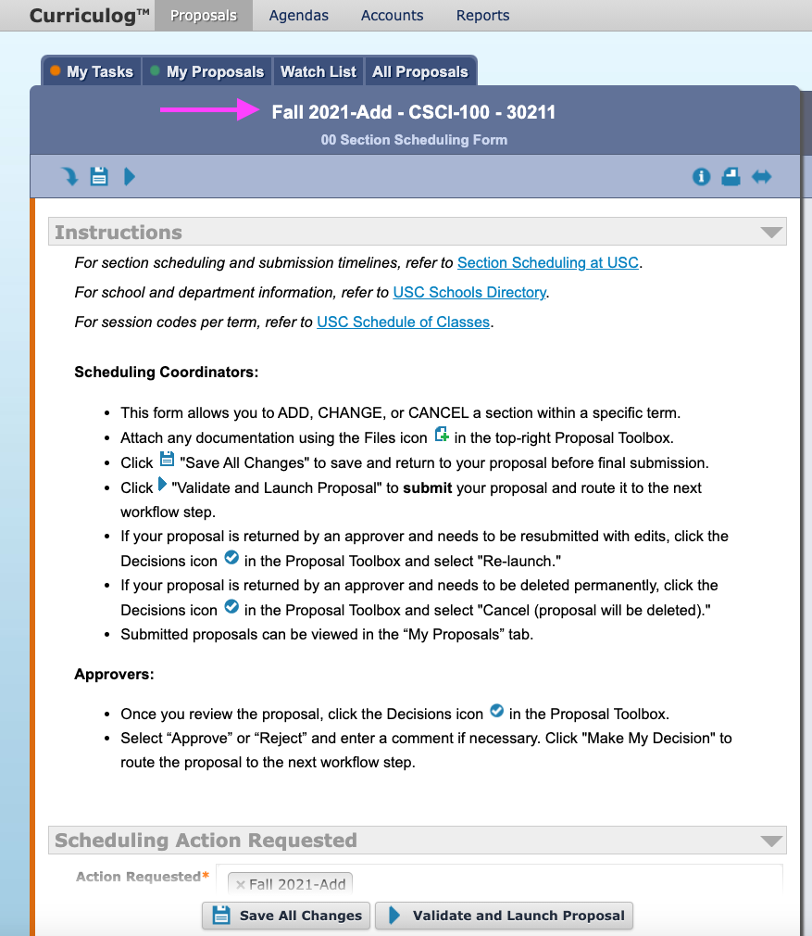
**Please refer to p. 50 to see how you can go back and continue to fill out your incomplete proposal.

For Scheduling Coordinators: How to “VALIDATE AND LAUNCH PROPOSAL” (SUBMIT A PROPOSAL)
When the scheduling coordinator completes a proposal and the proposal is ready to move onto the next step in the workflow, they can Validate and Launch it in two ways:
- Click Validate and Launch Proposal, which is always visible at the bottom of your screen at all stages of your data entry.

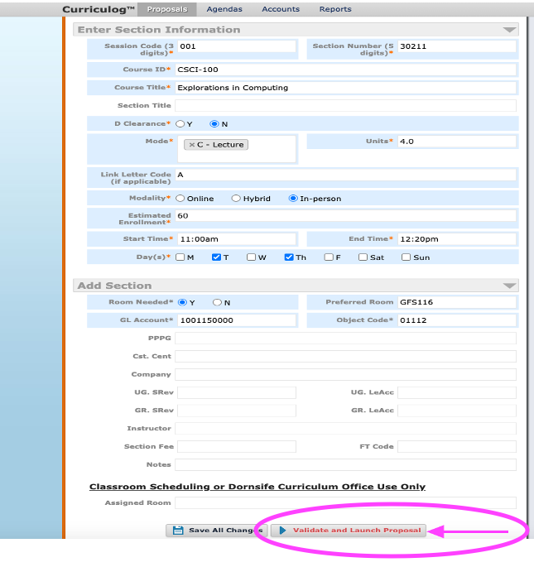

- Or, click Validate and Launch Proposal (the blue triangle icon) at the top of the form:
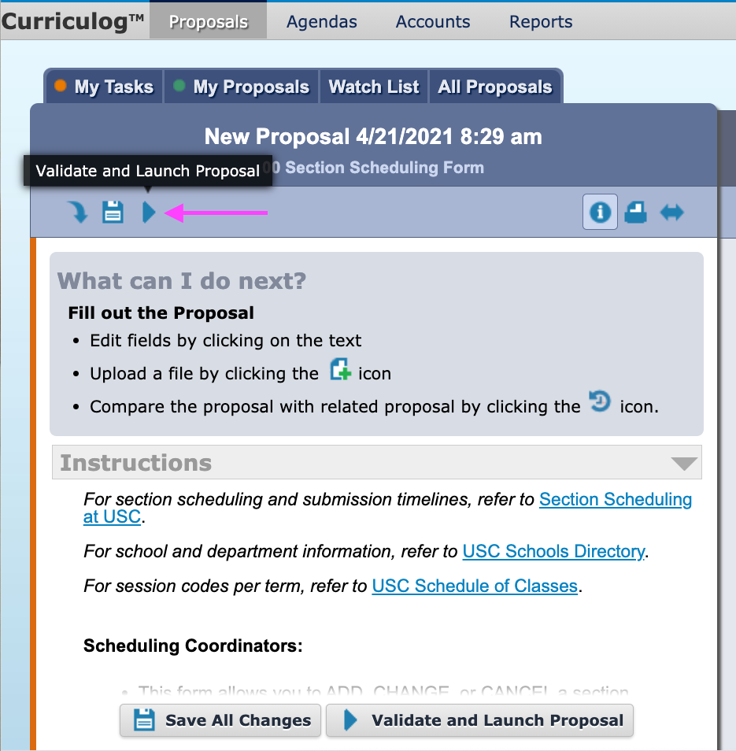

After clicking Validate and Launch Proposal, a small window will appear with brief information about the next steps.
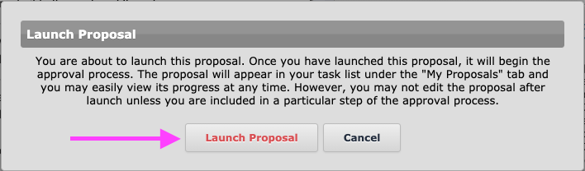
Before proceeding with the final step to submit your proposal, the proposal’s Status bar will indicate an Unlaunched status. To complete your submission, click Launch Proposal:
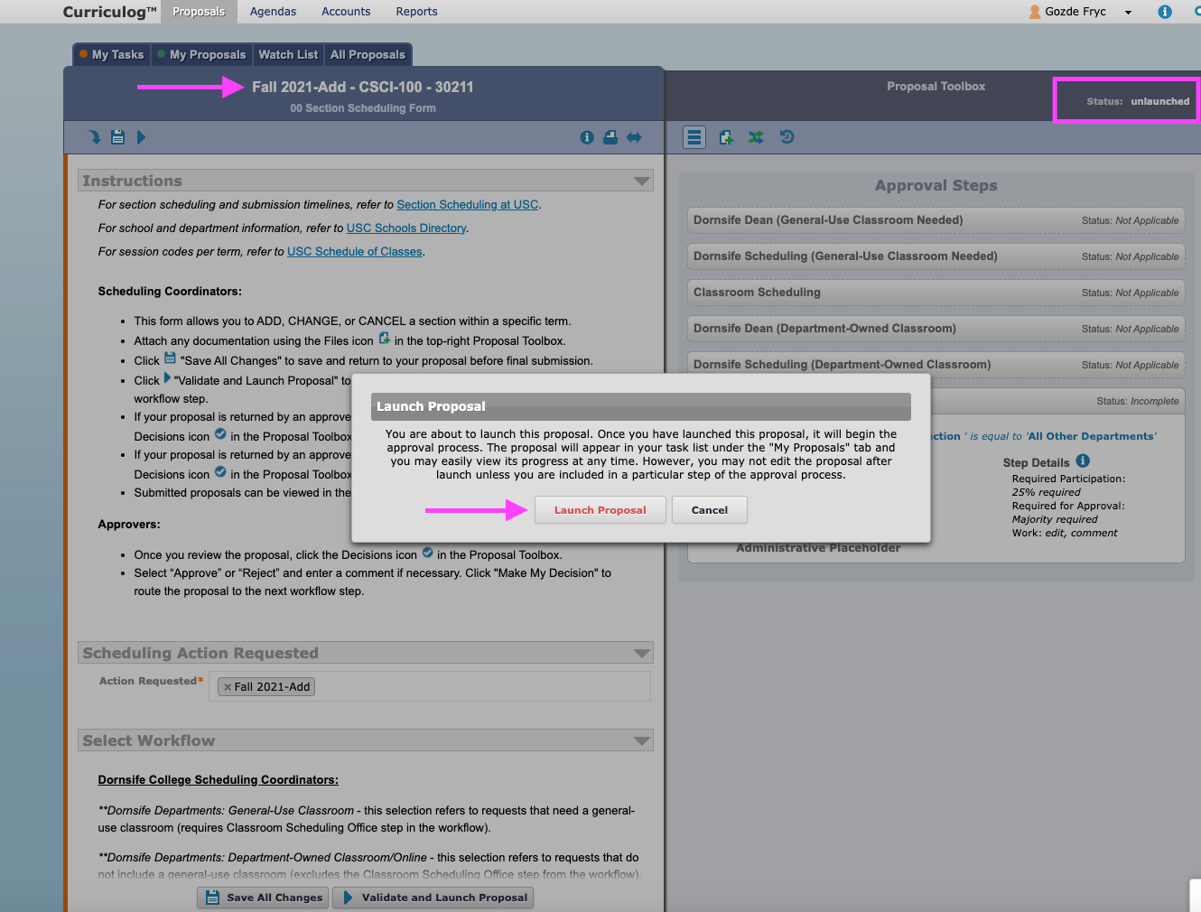

After you click Launch Proposal, the proposal will be updated for the next step of the process:
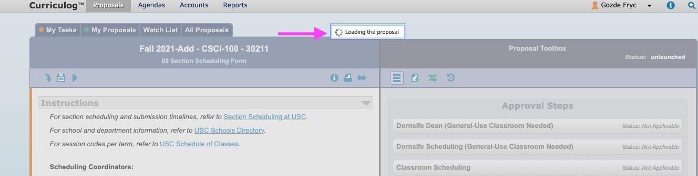
When the proposal is successfully launched, a notification will appear informing you about the next workflow step:
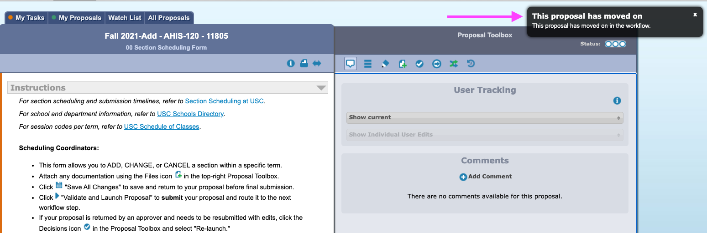
In addition, hovering over the status bar will allow you to see which office is next in the workflow. In the example below, it notifies the user that “Dornsife Dean (General-Use Classroom Needed) Current” is the next step (due to the “All Other Departments” workflow selection):
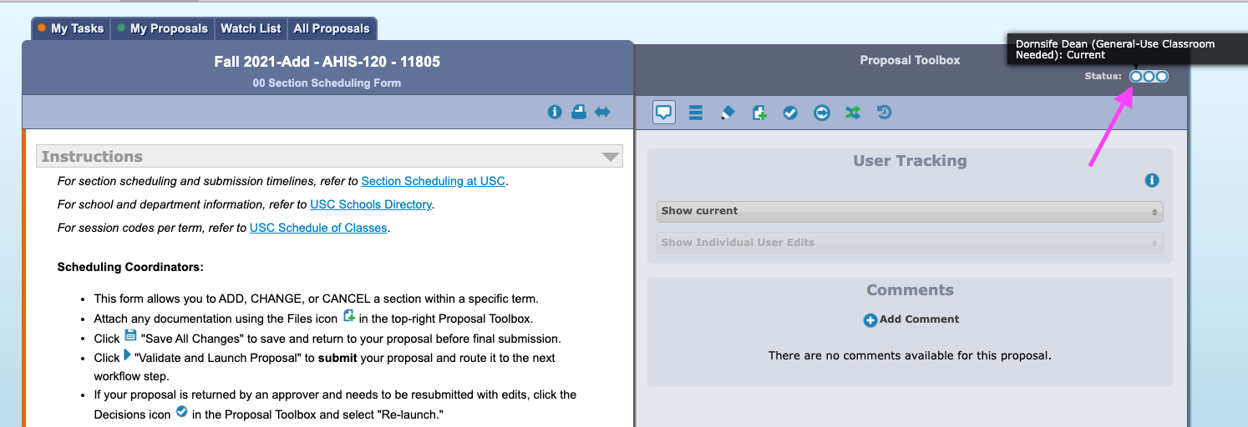

FOR Scheduling Coordinators and Approvers: Workflow General Information and Progress Tracking
There are three workflow approval routes depending on the selection you make in the Select Workflow field:
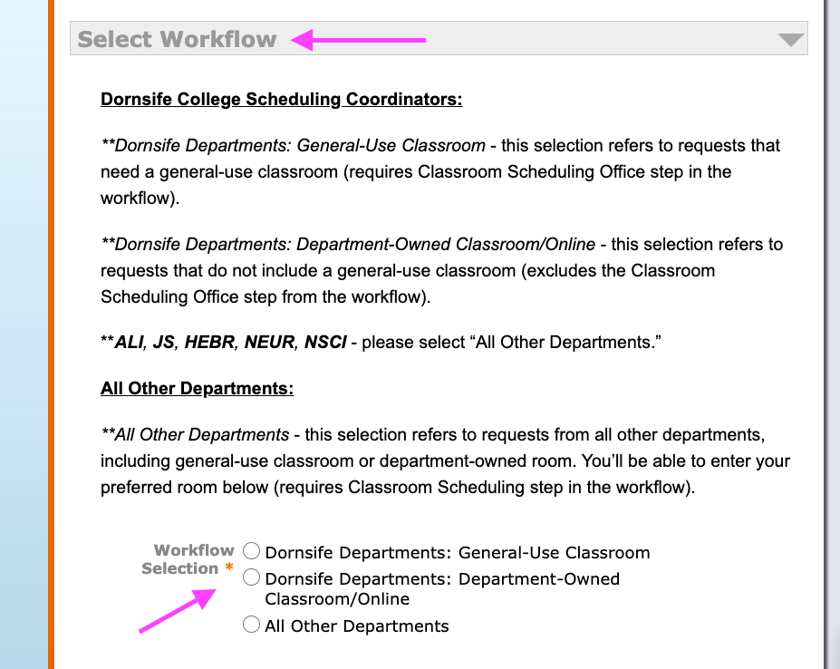

Dornsife Departments: General Use Classroom:
- Click the Workflow Status icon in the Proposal Toolbox (#1) and the steps of the workflow approval process will become visible.
- There are three steps in this workflow process, so there are three circles in the status bar indicating each step (#2). This is where you can track the progress of the proposal.
- Once the proposal is approved by the Dornsife Dean, it moves to the Dornsife Scheduling Officer, as indicated by a checkmark in the first circle.
- Once the proposal is approved by the Dornsife Scheduling Officer, it moves to Classroom Scheduling Office, as indicated by a checkmark in the second circle.
- Once the proposal is approved by the Classroom Scheduling Office, the status bar indicates “Status: completed,” which is the end of the workflow approval process.
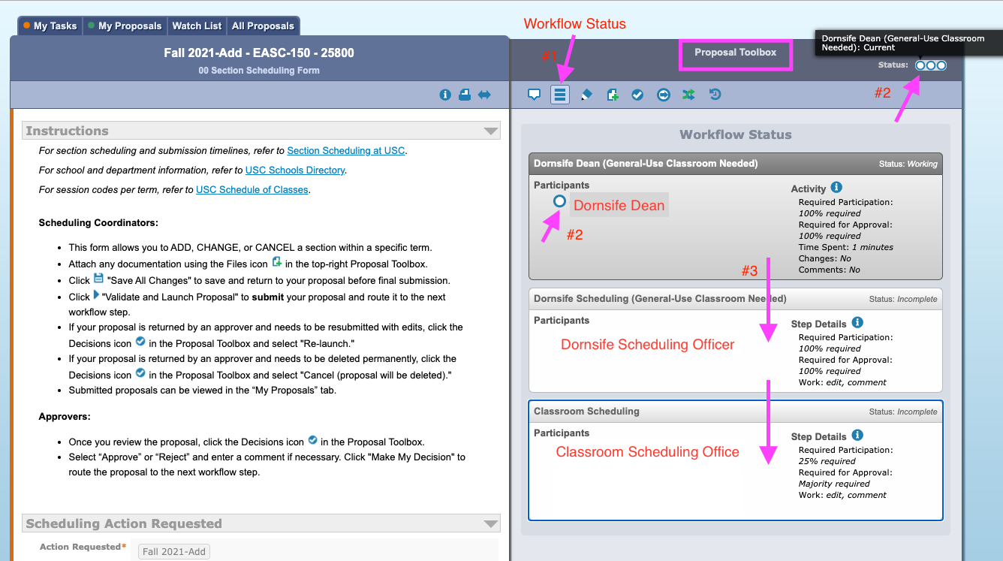

Status: completed
The following screenshot depicts status levels at each workflow step.
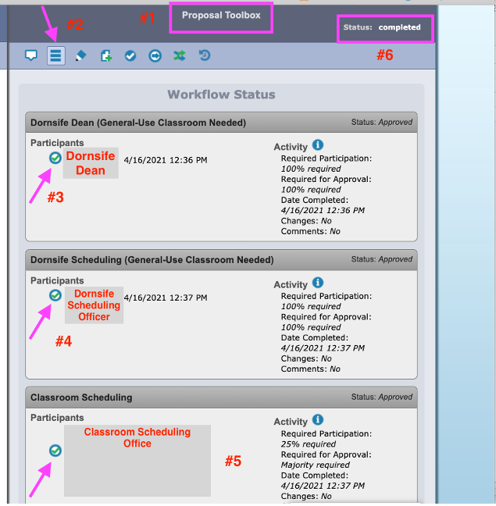

Dornsife Departments: Department-Owned Classroom/Online:
In this workflow selection, the process ends when the Dornsife Scheduling Officer approves the proposal, at which point the status of the process reaches “Completed.” This workflow selection excludes the Classroom Scheduling Office because a general-use classroom has not been requested.
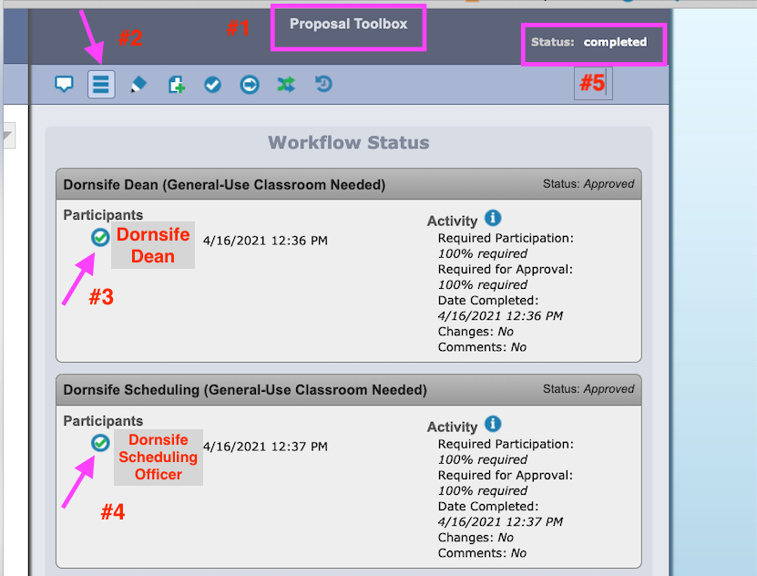

All Other Departments:
In the Proposal Toolbox(#1), click Workflow Status (the three lines icon) (#2) to see the stage of your proposal, which is incomplete in the example below since the circle in the Status progress bar is empty (#4). You can see the office in the next workflow step.

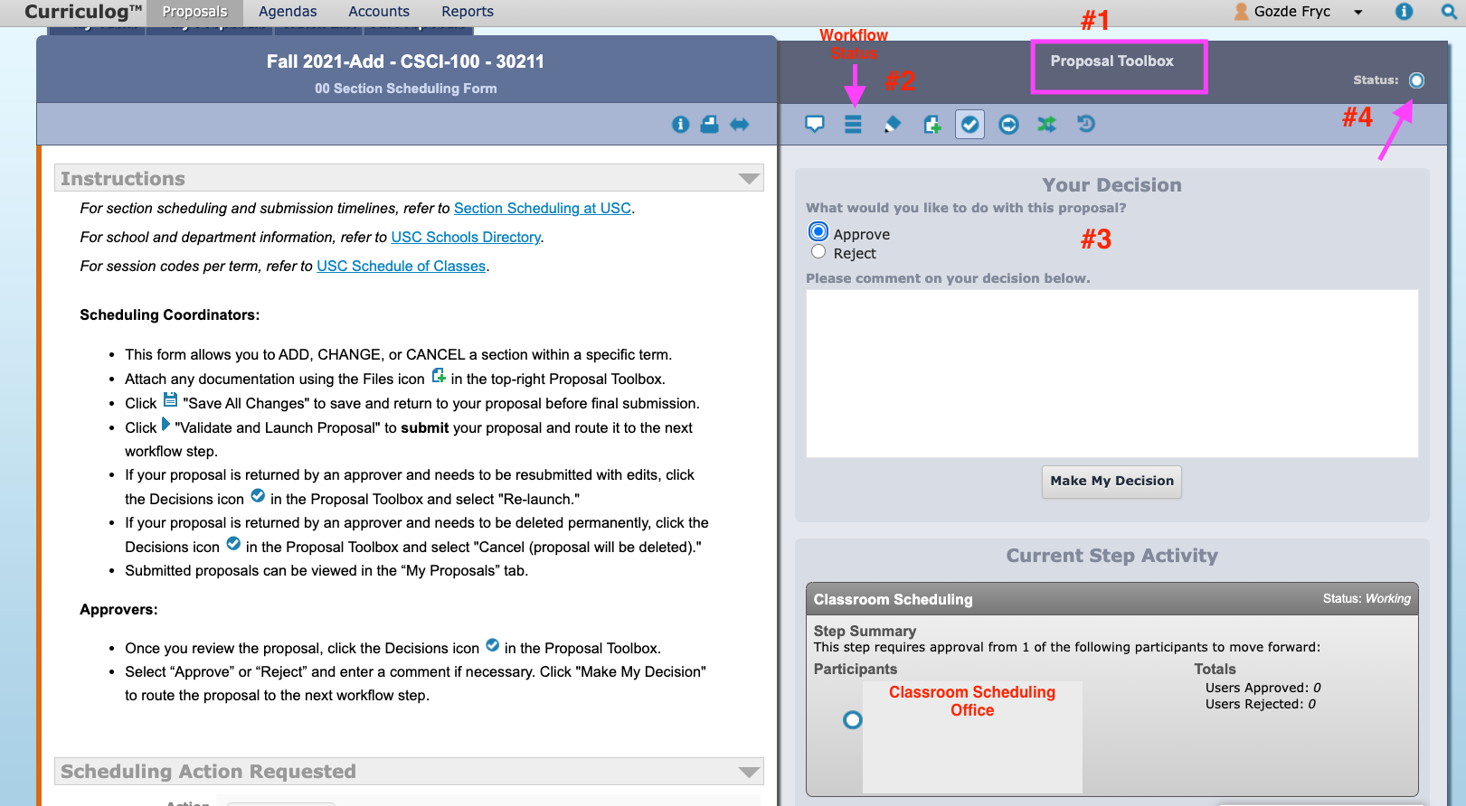
In this workflow selection, the process ends when Classroom Scheduling Office approves the proposal. Then, the status of the process reaches completed. This workflow selection includes only the Classroom Scheduling Office regardless of the type of room needs.
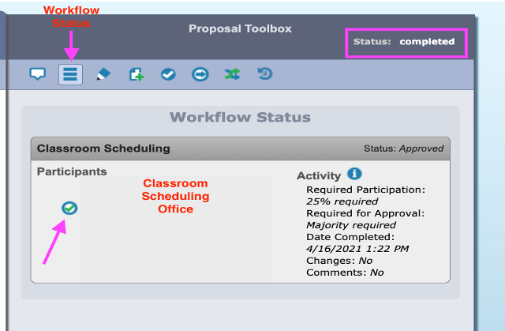

For Dornsife Curriculum Office: How to Approve a proposal
There are two options to process and approve a proposal: (1) open the proposal and process the details, or (2) approve multiple proposals from the My Tasks tab.
Option 1:
The scheduling coordinator selects a Dornsife Departments option in Select Workflow…

…and validates and launches the proposal. The proposal will land in My Tasks tab (#1). You can click Edit Proposal (#2) to open the proposal. You can also access the proposal from My Dashboard (#3), where you can open the proposal by directly clicking “Click here” (#4):
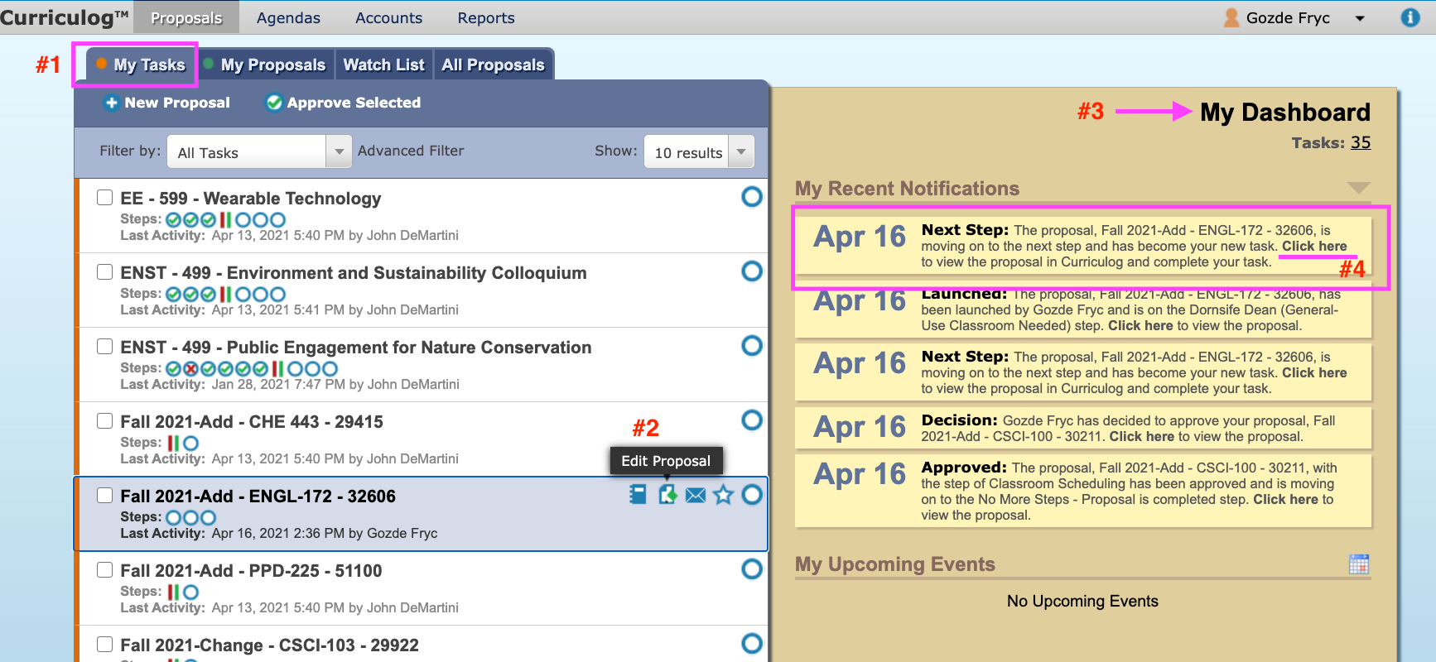

NOTE: In addition, you can also access the proposal via email (refer to pp. 47, 49).

To approve a proposal:
Step 1: The first approver in the Dornsife Curriculum Office is the Dornsife Dean in the workflow approval process. When it is time to move the proposal to the next workflow step, click the Decisions icon in the Proposal Toolbox.
Step 2: If the decision is to approve the proposal and move it to the next step in the workflow, click Approve and then Make My Decision. Adding a comment is optional at this stage.
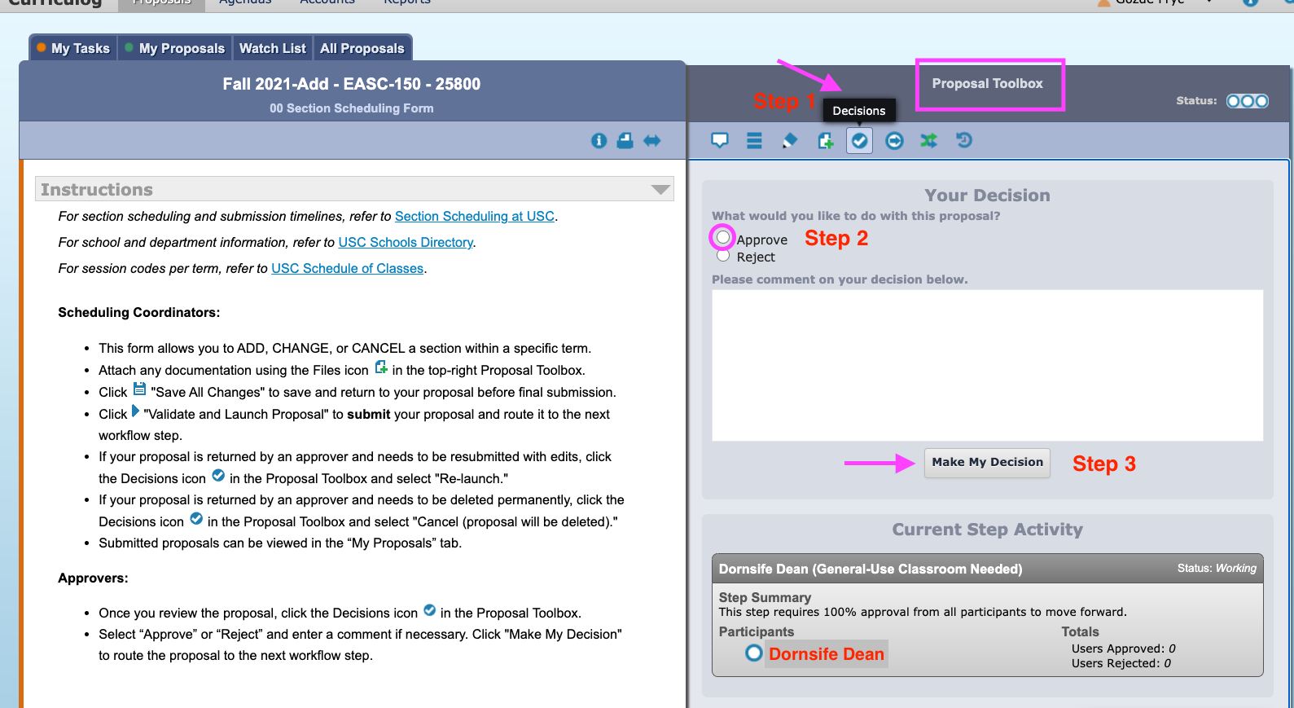
Step 3: After the Dornsife Dean’s approval, the proposal moves to the Dornsife Scheduling Officer and lands in the officer’s My Tasks tab.
Step 4: After performing the requested action (Add Section, Change Section, Cancel Section), the Dornsife Scheduling Officer approves the proposal to move it to the next step in the workflow. Step 2 is repeated by the Dornsife Scheduling Officer.
*NOTE: If “Dornsife Departments: General-Use Classroom” is selected by the scheduling coordinator, with the Dornsife Scheduling Officer’s approval, the proposal moves to the Classroom Scheduling Office and with CS Office’s approval, the Status of the proposal reaches completed status.

**NOTE: If “Dornsife Departments: Department-Owned Classroom/Online” is selected by the scheduling coordinator, with the Dornsife Scheduling Officer’s approval, the Status of the proposal reaches completed status.
Please refer to pp. 34, 35 for completed status info for the proposals that go through Dornsife Curriculum Office’s approval process.
Option 2:
One or more proposals can be Approved at the same time in My Tasks tab (#1). Please note this option is possible only to Approve the proposal(s). To approve multiple proposals without opening each one separately, you can select all the proposals you’d like to approve by clicking the box next to each proposal (#2). After you select the proposals you’d like to approve, click Approve Selected (#3). When you approve the selected proposals, the proposal(s) will move to the next step in the workflow.
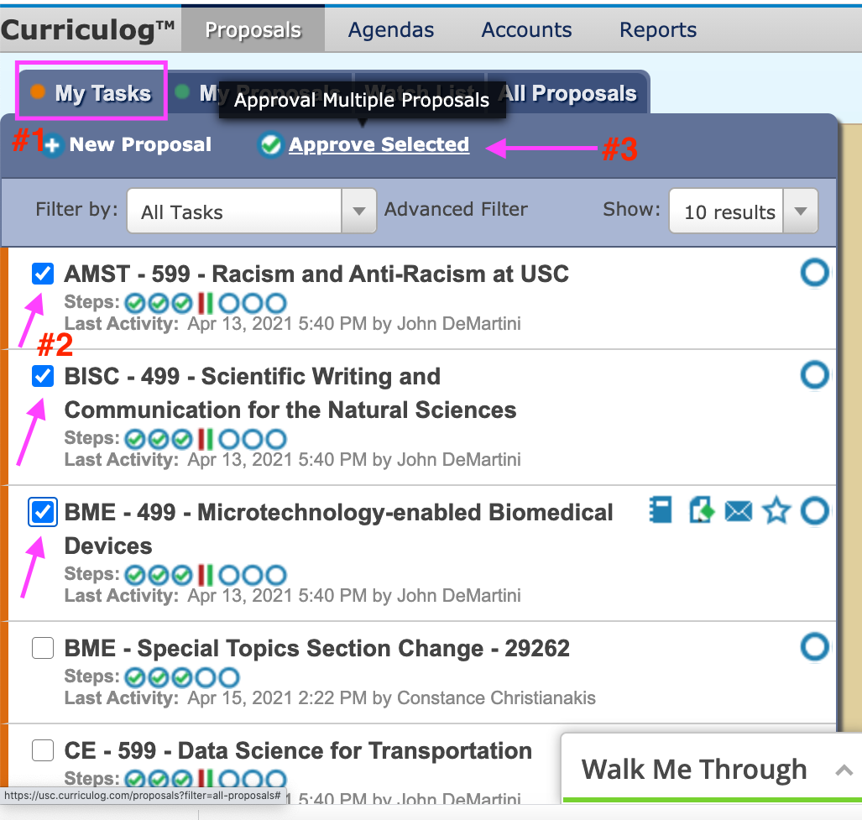

For Dornsife Curriculum Office: How to Reject a Proposal
If a proposal needs to be returned to the previous step in the workflow for further editing, in the Proposal Toolbox (#1), the approver clicks Reject (#3) in the Decisions (#2) field. Adding a comment to the comment box (#4) is required when a proposal is rejected. After adding a comment, click Make My Decision (#6). Clicking Make My Decision sends the proposal back to the scheduling coordinator for further editing. At the stage, the proposal remains in an incomplete status (the status bar--the three circles next to Status-- indicates the proposal is in an incomplete status (#5)).
NOTE: A proposal can be rejected at any stage of the workflow process (by Dornsife Dean or Dornsife Scheduling Officer or Classroom Scheduling Office) and returned to the scheduling coordinator.
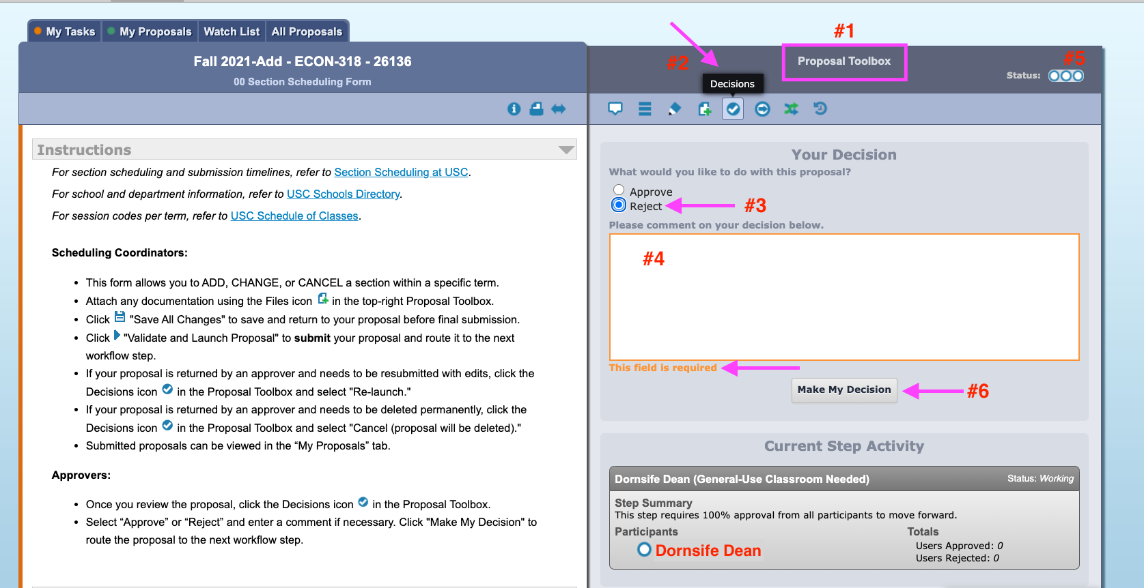

For Scheduling Coordinators: How to Re-Launch (re-submit) a rejected proposal
When a proposal is rejected, it returns to the scheduling coordinator for further editing. The scheduling coordinator can locate the proposal in My Tasks tab (#1), My Proposals tab (#1) and My Dashboard (#3). In the My Tasks or My Proposals tab, click Edit Proposal (#2) to open and edit the proposal. In My Dashboard, you can click “Click here” (#4) and directly access the proposal.
NOTE: You can see the rejected icon (x) in the first circle and the incomplete status (#5) under the name of the proposal that is rejected and returned to the scheduling coordinator.
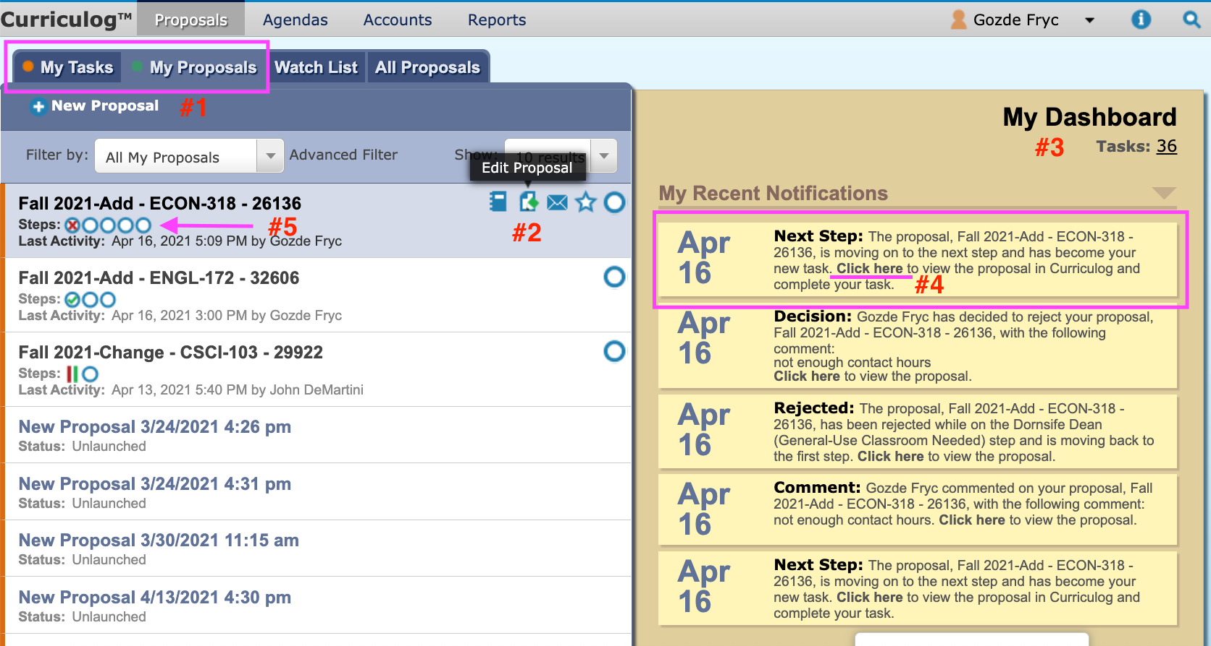

The scheduling coordinator makes the changes requested in the Comments field (#3) in Proposal Toolbox (#1). A response to the comment can be sent by clicking Reply (#4) if needed.
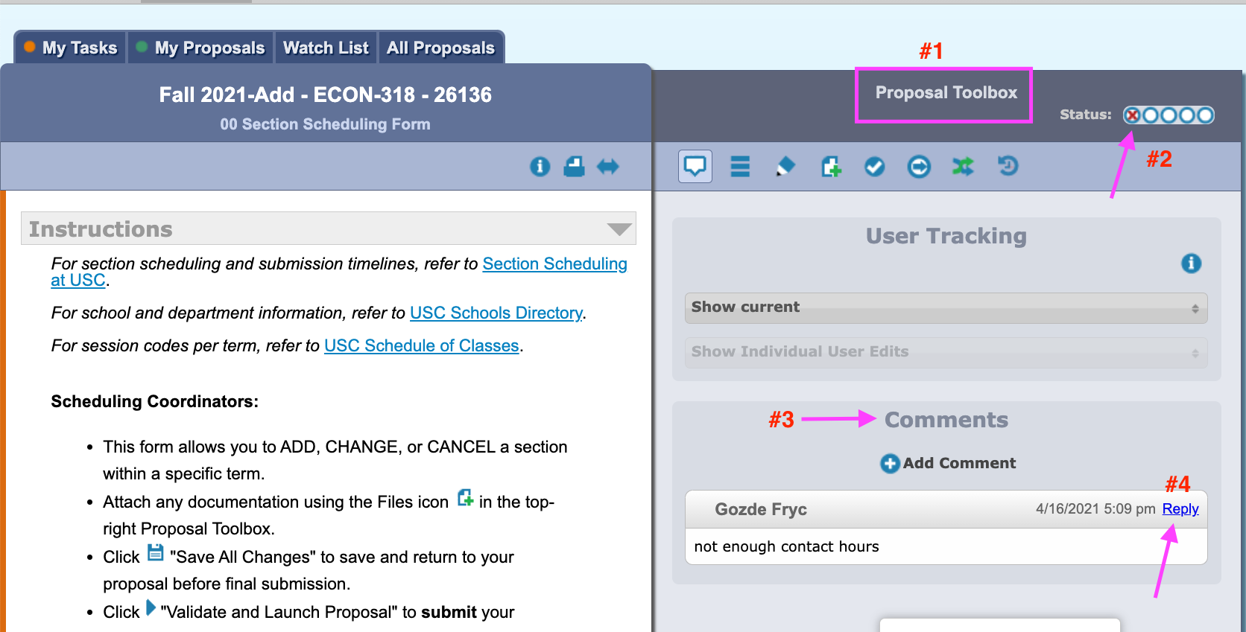

After making the changes to the proposal, you can click Decisions (checkmark icon) (#2) in Proposal Toolbox (#1) and select Re-Launch (#3) to re-submit the same proposal. Then, click Make My Decision (#5) to move the proposal to the next step in the workflow. This will re-start the approval process from the beginning. There is no need to start a new proposal for requested changes.
NOTE: If you decide to discontinue the proposal, you can cancel it (it will be deleted permanently) by clicking Cancel (#4). To proceed with the cancellation, a comment (#4) is required before clicking Make My Decision (#5).
NOTE: The rejection decision and incomplete status can be seen in the Status progress bar (#6).
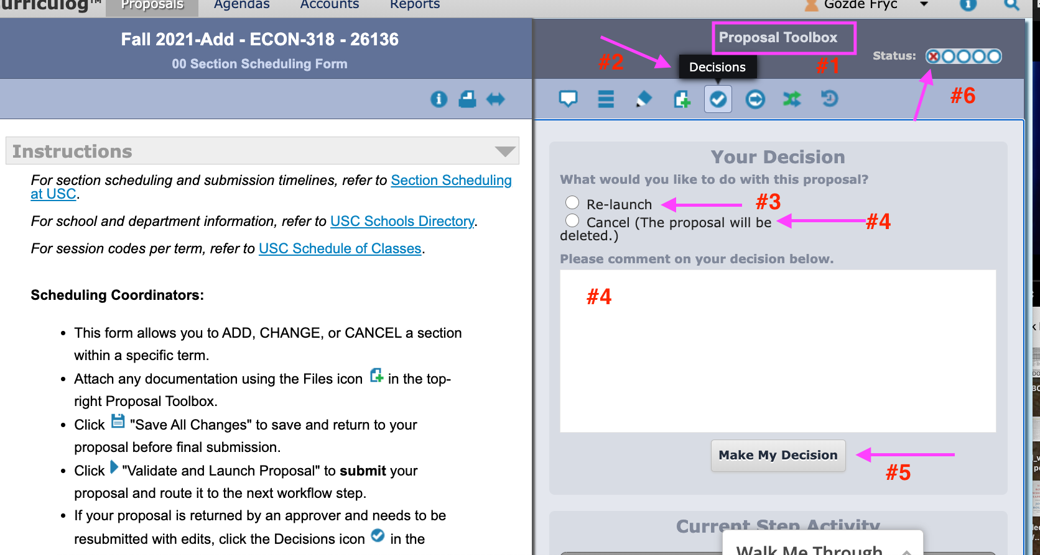

How to set up Email Notifications
Curriculog sends an email notification for each action taken for a proposal informing the users that a proposal is initiated, a decision or change is made, a comment is added, a proposal is at the next step in the workflow, a proposal is rejected, or the status of a proposal is complete.
The user has two main options for receiving the proposal email notifications about a proposal they are involved with either as a scheduling coordinator or as an approver.
The user can adjust the type and frequency of the email notifications by:
Step 1: Hover over your name, and then select My Settings

Step 2: Click on your information in My Settings tab
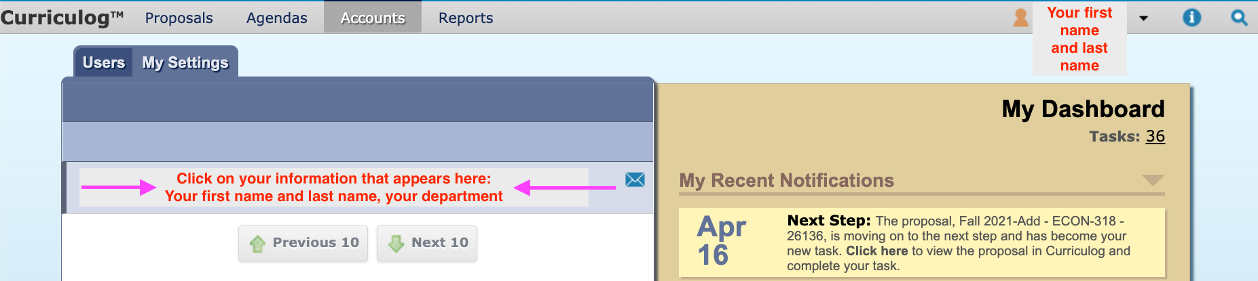

Step 3: From the Account Summary that appears, scroll down to User Rights (#1).
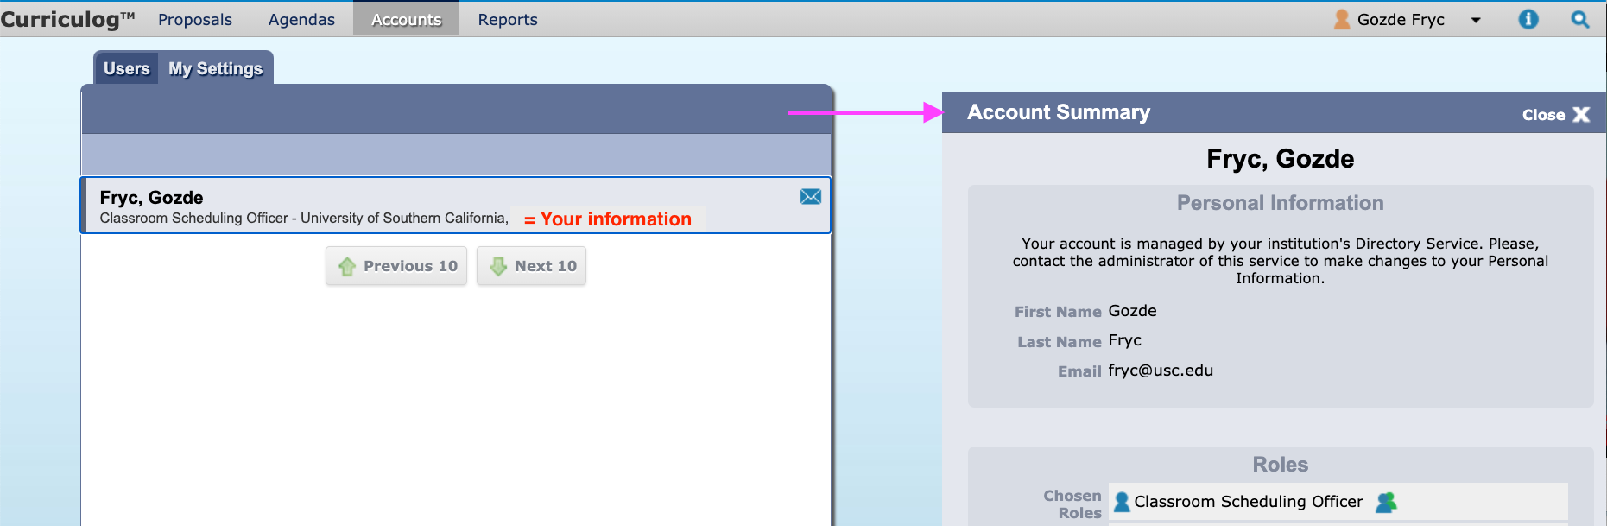

To receive one email per day with the list of all proposals you started or were a part of the previous day, select “Get all messages for user’s proposals” in Originator (#2), “Daily Email Digest” in Email Options (#3), and “Send messages for the steps in which I am involved only” in Process (#4).
Once you make your selections, click Save Preferences (#5).

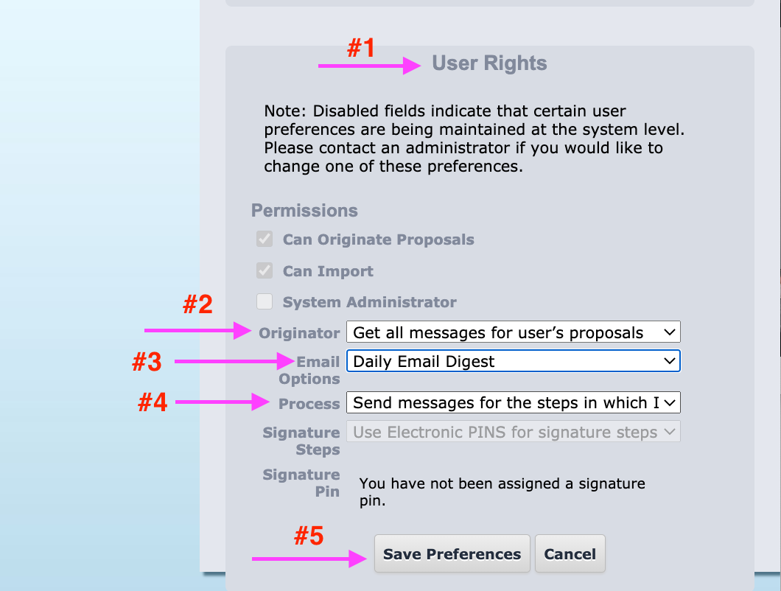
Example:
The Curriculog Daily Digest (#1), (#2) email notification about the previous day’s proposals and actions you are involved in (#3) is sent to your @usc.edu email address. In the email, each action taken regarding the same proposal is also linked to the proposal itself in Curriculog via a hyperlink. Click Click here (#4) to directly access the proposal.
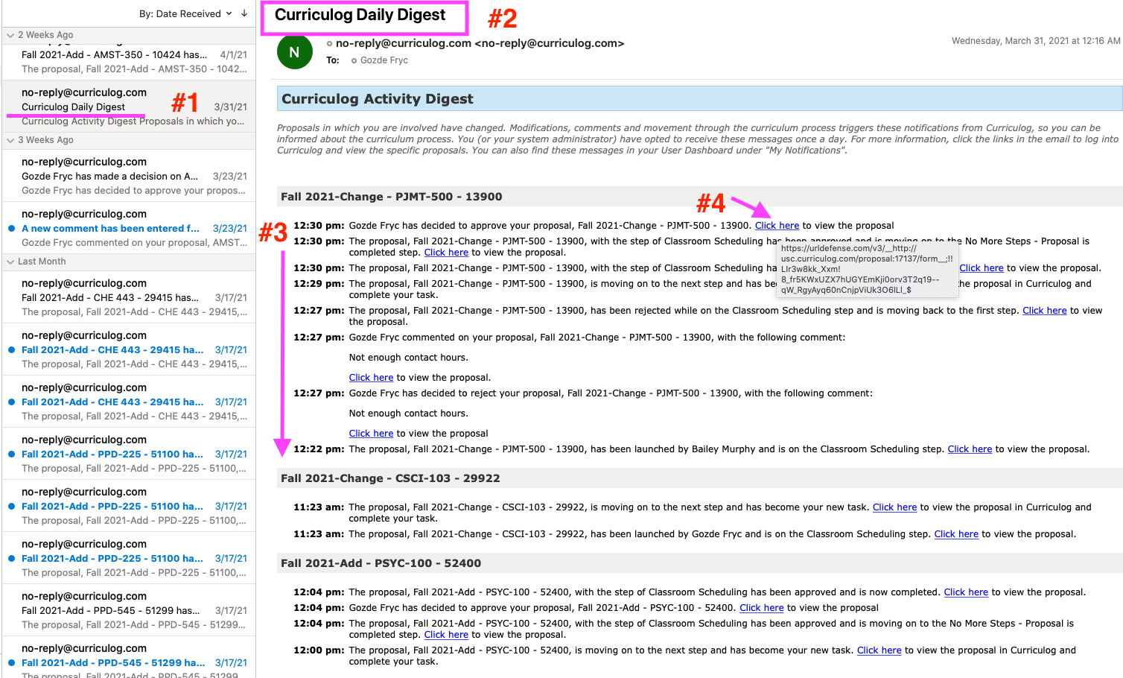

If you select All Emails in Email Options, you’ll receive an email message for each action taken for each proposal in real time.
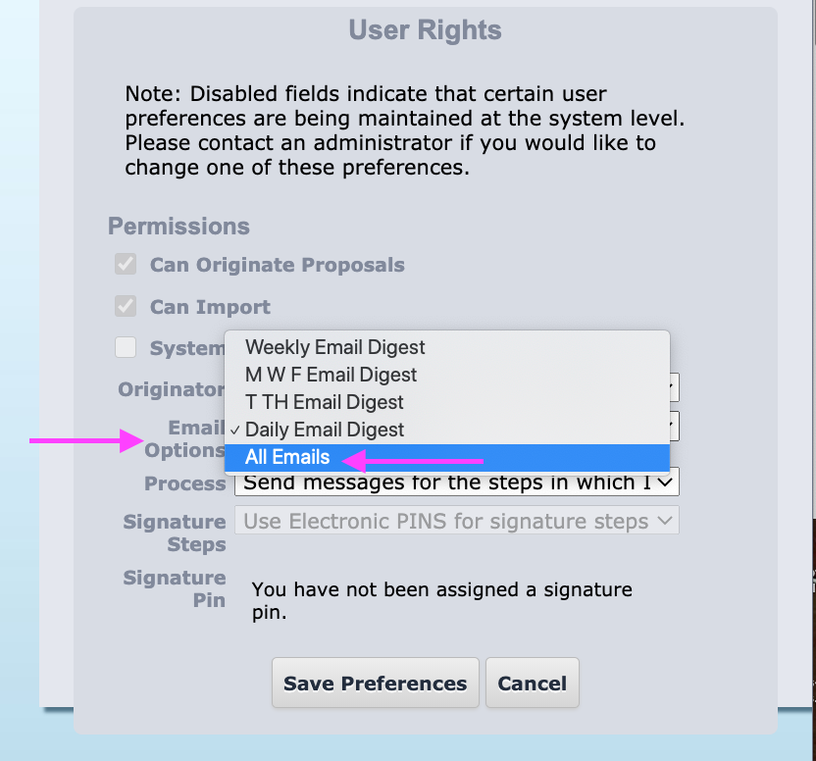

Example:
If All Emails is selected, one email message is received for each action taken for a single proposal. The subject line of the email notification matches that of the proposal’s (#1). There is direct access to the proposal from the email message via Click here (#2).
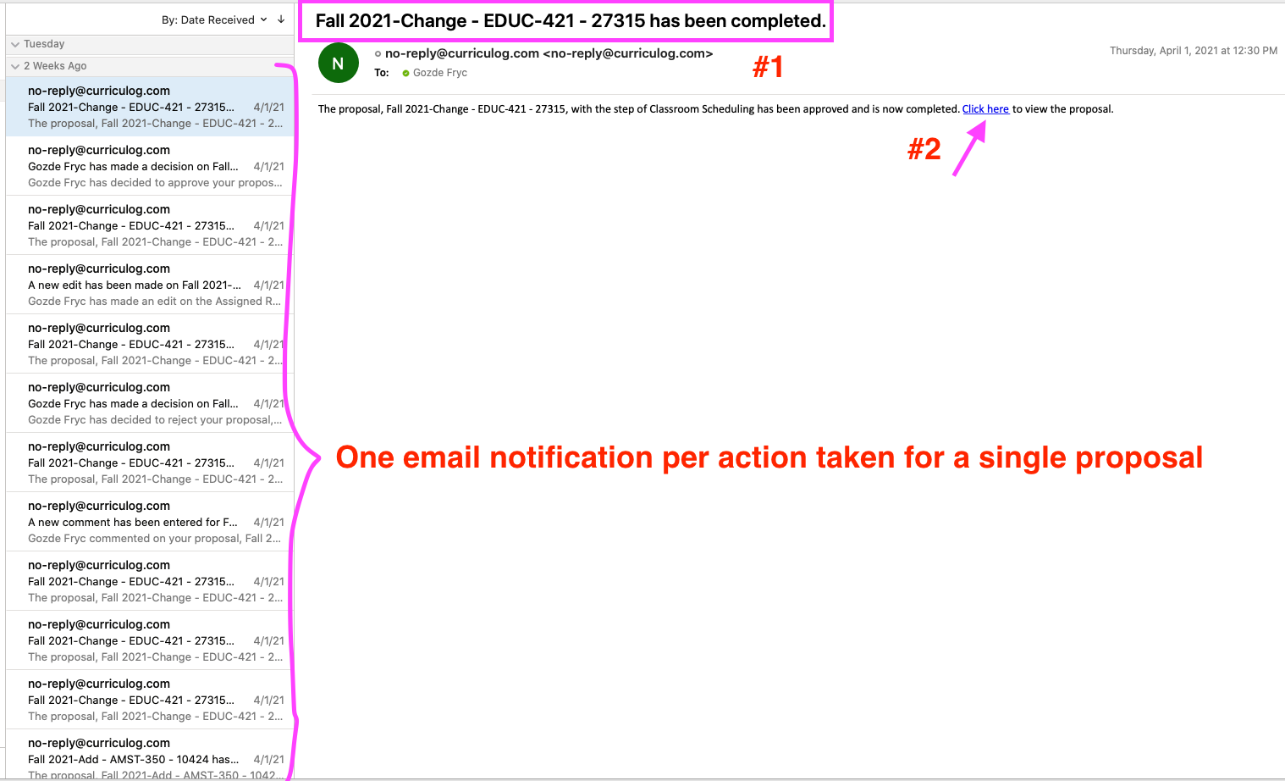

How to search for a proposal

For Scheduling Coordinators:
- If the scheduling coordinator clicks Save All Changes (p. 25), the proposal remains in an “unlaunched” status (#2). Unlaunched proposals are listed in the My Proposals (#1) tab. The scheduling coordinator clicks Edit Proposal (#3), which opens up the proposal for further editing or completion of data entry.
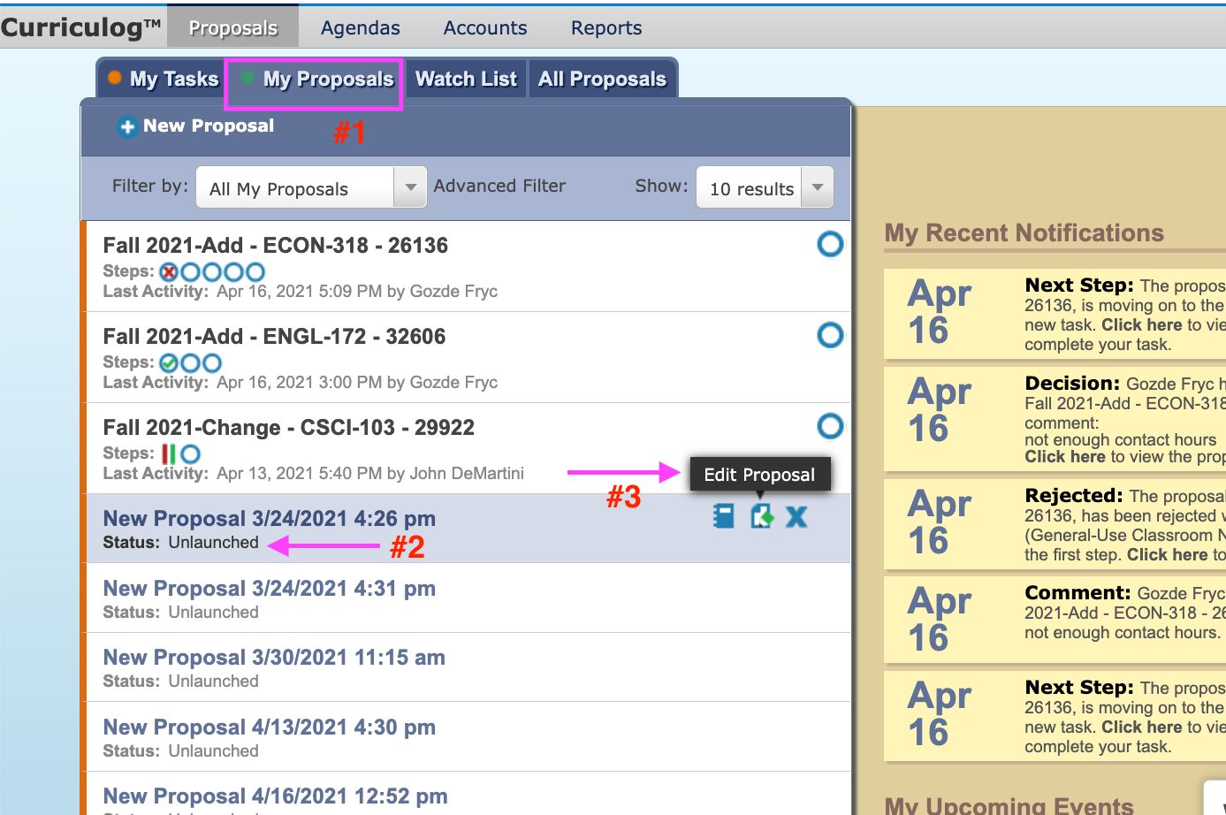

- If a proposal is rejected and returned to the scheduling coordinator, the proposal can be located in My Tasks, My Proposals, and All Proposals tabs.
(2.1) My Tasks
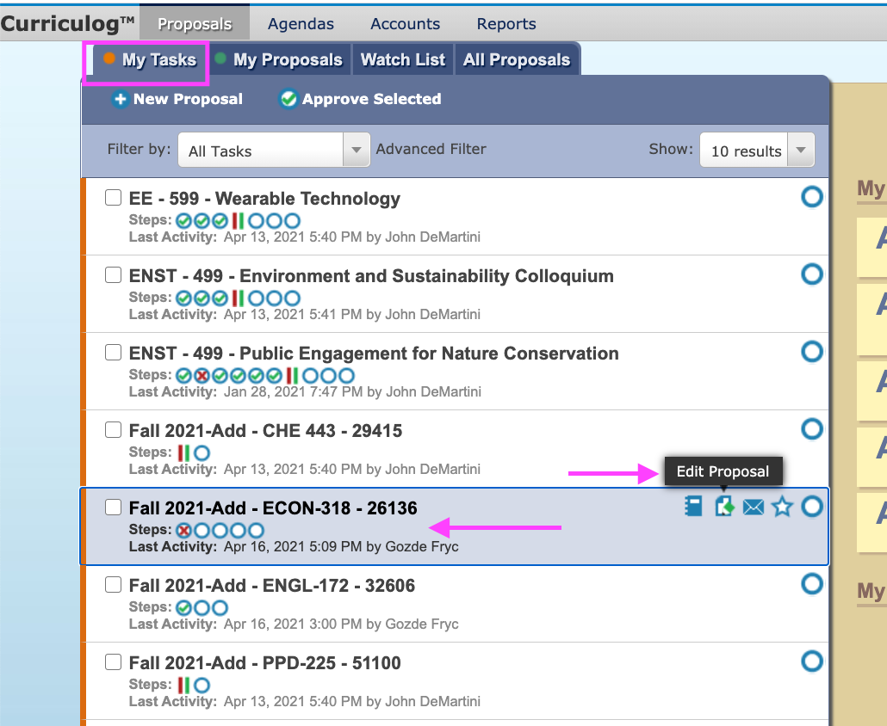
(2.2) My Proposals
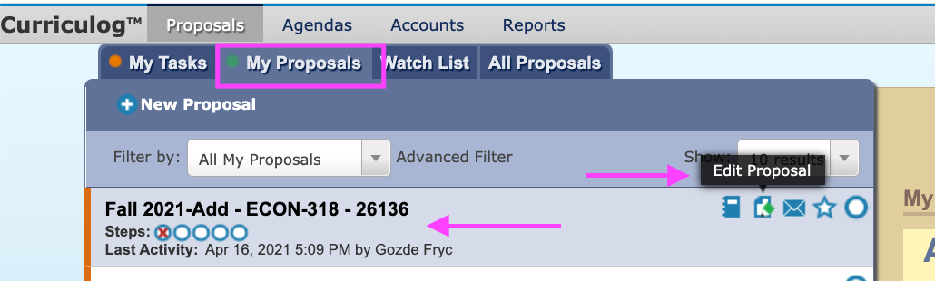

(2.3) All Proposals
Click Advanced Filter (#2) in All Proposals tab (#1). Select the school you selected when you filled out the proposal in Found Under (#3). Select the 00 Section Scheduling Form in Process Type (#4). Make sure the Completed box is left unchecked (#5). Manually enter the section number (or any data item in the name of the form; e.g., Fall 2021; Add; ECON 318; 26136) of the proposal you are looking for (#6). Click Filter Proposals (#7). All proposals processed for that section number will be listed below (#8). Click Edit Proposal (#9) to complete the form.
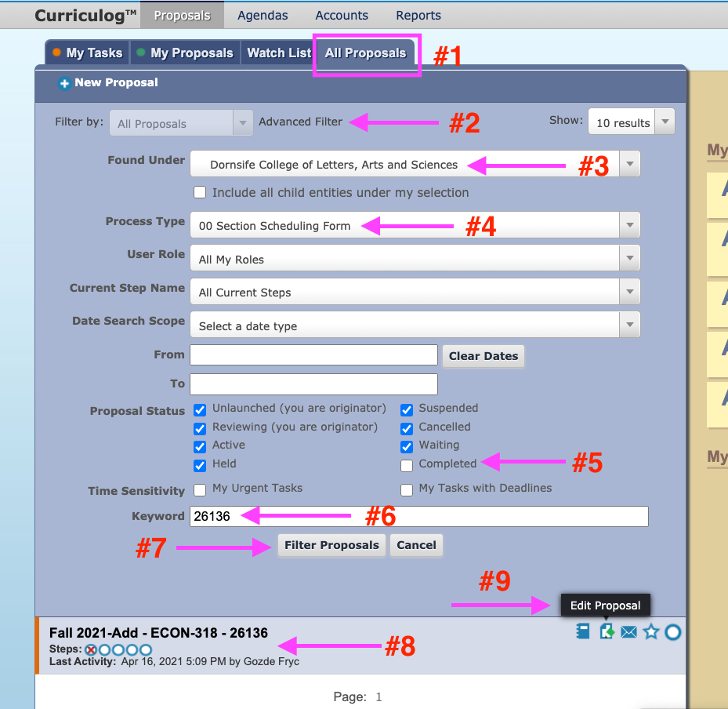

For Approvers:
A proposal launched (submitted) by the scheduling coordinator lands in My Tasks (#1) tab and awaits your approval. You can access the proposal by clicking Edit Proposal (#2). The same proposal can be accessed from My Dashboard (#3) via “Click here” (#4).
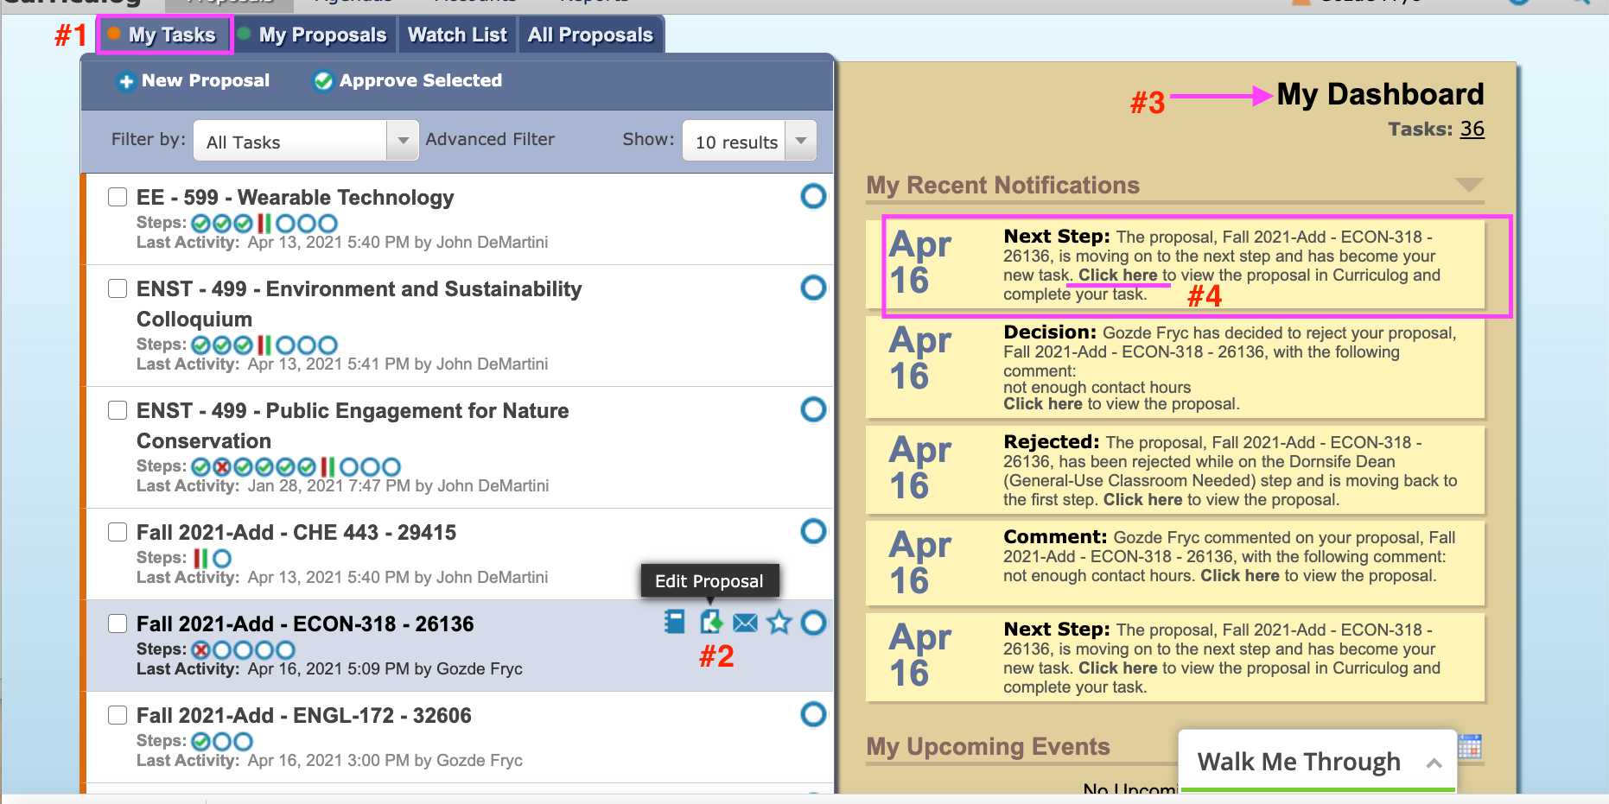

For Scheduling Coordinators and Approvers:
- Every new proposal has a unique URL (#1). At any status, your proposal (unlaunched, incomplete, rejected, complete) can be accessed via this URL.
Example: https://usc.curriculog.com/proposal:17055/form (#1) is the unique URL for Fall 2021-Add – CHE 443 – 29415 (#2).
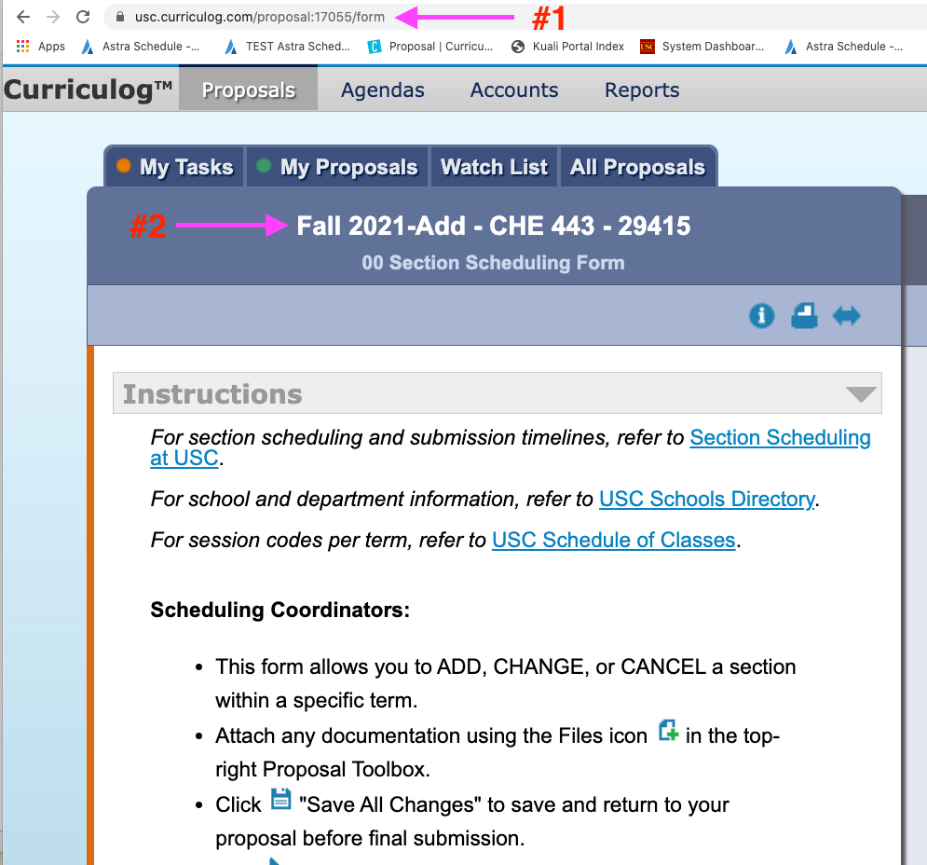

- Proposals with a complete status (#7) can be accessed via the Advanced Filter in All Proposals tab (#1) in addition to the unique URL. Make sure you check the Completed box (#4) to narrow down your search. Enter a key word from the name of the proposal (#5). The proposal can be viewed by clicking View Proposal (#8).
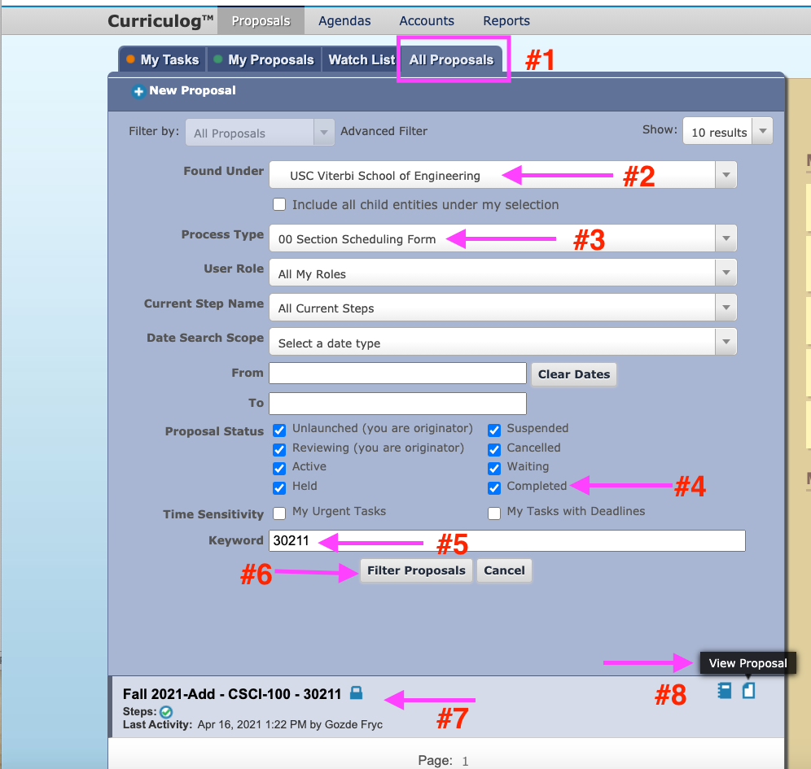

- An email message received via Daily Digest (#2) or All Emails contains a direct link to the proposal. Please refer to pp. 49 and 51 for details.
(3.1) Click “Click here” (#4) to directly access a proposal that awaits your attention or a proposal that you need edit/refer to.

(3.2) If the All Emails (#1) option is selected from the Settings, the proposal you are looking for can be accessed from a direct link provided in each email message. Click “Click here” (#2) to access the proposal you are looking for.

For questions and issues
If you have questions and/or issues regarding the Section Scheduling Form, please contact the Classroom Scheduling Office at classroom.scheduling@usc.edu.

