Understanding Free Electives and How to Calculate Free Electives
Free electives are courses students can take in addition to required course requirements to reach the units necessary to graduate (128 units for most undergraduate majors).
To calculate free electives, add the required Major Core, and General Education Core (Writing, FLAN, Gen Ed) units and subtract them from the university's total units required for graduation.
The Calculation Formula
The formula to determine free elective units is:
$$\text{Total} \text{Units} \text{for} \text{Degree}-\left(\text{Major} \text{Core}+\text{Gen} \text{Ed Core}\right)=FREE ELECTIVES$$
Step-by-Step Breakdown
- Find the total units required for graduation: Most bachelor's degrees require 128 units. Check the USC Catalogue or STARS for verification.
- Add up the students’ non-elective requirements: Add the units needed for all specified major courses, required general education core classes, and mandatory major electives.
- Subtract from the total: Deduct this sum from the total degree units.

Example: If a program requires 128 units to graduate, and the Core Major (60) + Gen Ed (48) total 108 units, there are 20 units of free electives in the program (128-108 = 20).
Things to Keep in Mind
What counts: Free electives (also called "open electives") allow students to take almost any undergraduate 100-level and above course outside of their major/GE core to reach the total unit requirement.
Minors, Dornsife Intensives, and second majors: If students use free electives to pursue a minor, intensive, or a second major, those specific courses will fill up their electives "bucket".
Check the STARS audit: The fastest way to see exactly how many free electives is to review the STARS report, to determine the total number of subject units $\left(\text{Major} \text{Core}+\text{Gen} \text{Ed Core}\right)$required (completed AND remaining) and calculate the allowable Free Electives.

Students pursuing double majors: In general, free electives are calculated based on the major most complete or most advantageous to the student in the semester of review.

Dornsife 104/96 Basic college requirement: A maximum number of professional school course work (course prefixes not taught in Dornsife) may apply to subject and free elective totals in Dornsife majors (24 max, or 32 max with active minor program).
Course work meeting two subject requirements: In some instances, a single course may meet multiple subject requirements. In these instances, the subject units required will be reduced by the value of the double counting course. These are the most common examples:

- A single course may satisfy a GE category A through F, and satisfy a Global Perspectives category G or H.
- A Major course requirement that also meets a GE category A through H.

Transfer credit impact on this calculation:
- Transfer credit from schools on the Quarter system are listed on STARS with two decimal positions, but are calculated by STARS using the full, untruncated value (e.g., 3.33 units calculates as 3.3333; 2.66 units calculates as 2.6666). When totaling quarter system units applied to subject requirements, it is important to use the full value provided in these examples.
- Transfer units meeting a subject requirement cannot be replaced by a USC course later taken that could satisfy the same subject requirement. For example, if a transfer course met category GE-A, and the student later took a major requirement that could also meet category GE-A, the USC course cannot be used to meet the GE category in this instance.
Calculation worksheet for advisor use:
Total Units for Degree = ________

Requirement | Units Required | Units Earned | Units Remaining
Writing
FLAN
GE Cat A-F
GE Global G-H
Major 1
Major 2
Major 3
Major 4
 | Total Subject Units Required=____

Total Units for Degree - Total Subject Units Required = FREE ELECTIVES

Sample #1 STARS Report (Business Administration)
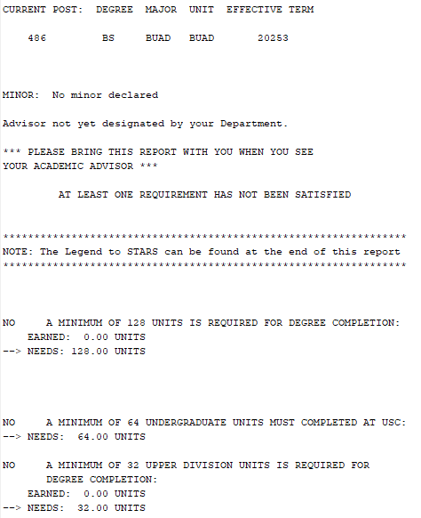
Step 2: Add up non-elective requirements
Step 1: Find total units required for graduation
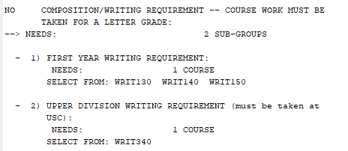
Writing: 8 units

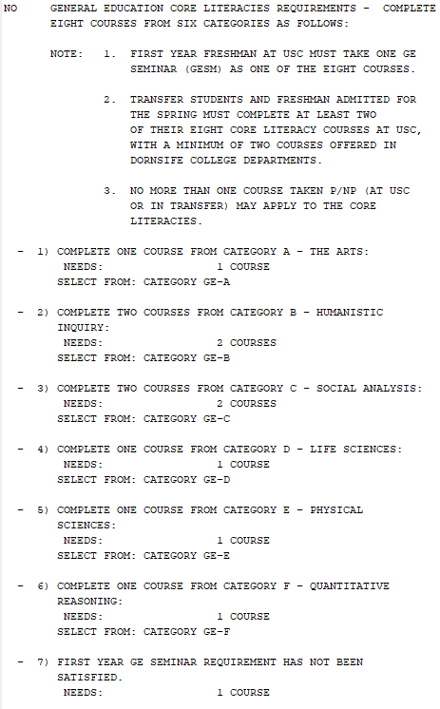
GE (Core Literacy): 32 units
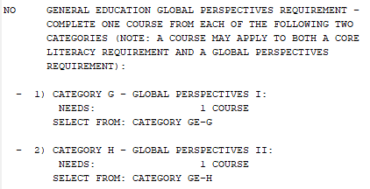
GE (Global Perspectives): 8 units
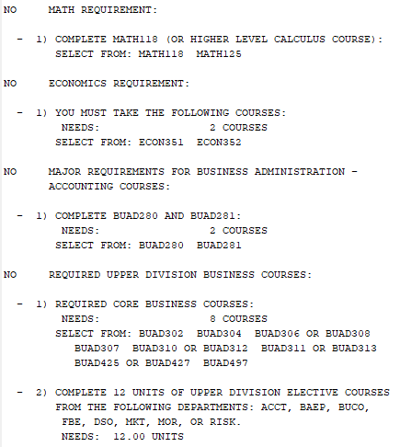
(30 units)
(6 units)
MAJOR: 48 units
MATH/ECON: 12 units

Calculation worksheet for advisor use:
Total Units for Degree = 128

Requirement | Units Required | Units Earned | Units Remaining
Writing | 8
FLAN | n/a
GE Cat A-F | 32
GE Global G-H | 8
Major 1 | 12
Major 2 | 48
Major 3
Step 3: Subtract the required subject units from the total units required
Major 4
 | Total Subject Units Required= 108

Total Units for Degree - Total Subject Units Required = FREE ELECTIVES
20
128 – 108 =

Sample #2 STARS Report (Business Administration)

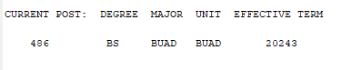
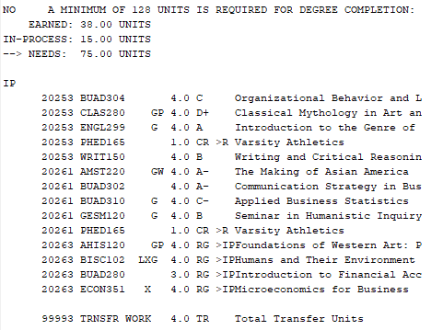
Step 1: Find total units required for graduation
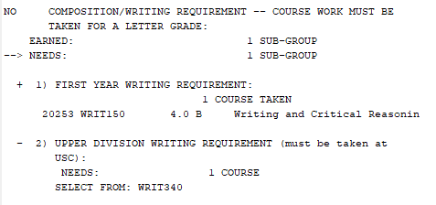
Step 2: Add up non-elective requirements

Writing:
Needs: 8
Earned: 4

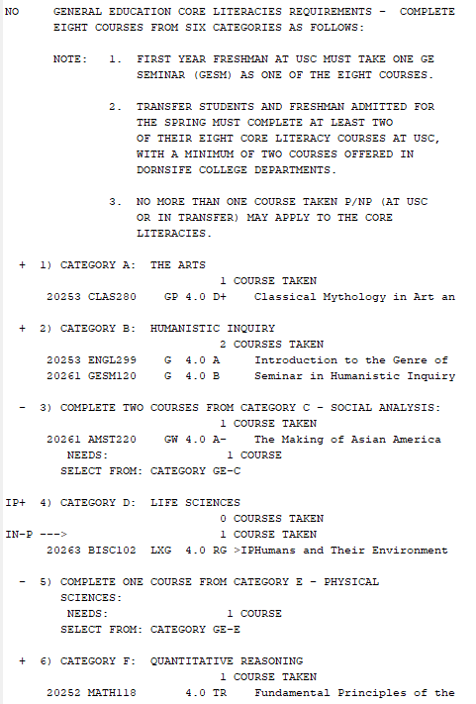
Double counts in major req
GE (Core Literacy):
Needs: 28
Earned: 16

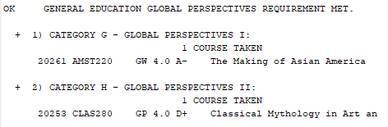
Double counts with GE-A
Double counts with GE-C
GE (Global Perspectives):
Needs: Zero Units
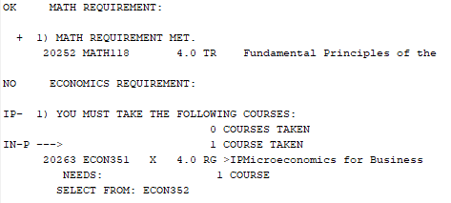
MATH/ECON:
Needs:12 units
Earned: 4 units

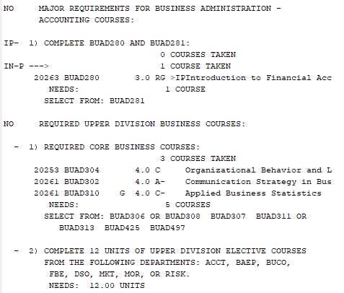
(30 units)
(6 units)
MAJOR:
Needs: 48 units
Earned: 12 units

Calculation worksheet for advisor use:
Total Units for Degree = 128
Step 3: Subtract the required subject units from the total units required
Requirement | Units Required | Units Earned | Units Remaining
Writing | 8 | 4 | 4
FLAN | n/a
GE Cat A-F | 28 | 16 | 12
GE Global G-H | 0 | 0 | 0
Major 1 | 12 | 4 | 8
Major 2 | 48 | 12 | 36
Major 3
Major 4
 | Total Subject Units Required= 96

Total Units for Degree - Total Subject Units Required = FREE ELECTIVES
32
128 – 96 =

